**“MEDICO PRIVATE LIMITED”**

**PROJECT DOCUMENTATION**









Medico Pvt. Ltd.

Data Analytics Implementation

Date: 16-Feb-2022

**Contents Page**

1. **EXECUTIVE SUMMARY 4**
   1. **Introduction 4**
   2. **Problem Statement 4**
   3. **Objectives of the Project 4**
   4. **Scope 5**
   5. **Tools & Technologies Used 7**
2. **BUSINESS REQUIREMENT SPECIFICATIONS 8**
   1. **Functional Requirements 10**
   2. **Non-functional Requirements 11**
3. **SYSTEM DESIGN 12**
   1. **Architectural Diagram 13**
   2. **Data Mapping 14**
   3. **ER Diagram 15**
   4. **Data Definition 15**
4. **DETAILED DESIGN 16**
   1. **Warehousing 18**
   2. **Reporting 19**
   3. **Machine Learning 20**
5. **IMPLEMENTATION & TESTING 21**
   1. **Data Ingestion using Fivetran 22**
   2. **Data loading using Snowpipe 24**
   3. **DBT Transformations 27**
   4. **Snowflake Development 29**
   5. **View & Tables 33**
   6. **Data Sampling & Secure Data Sharing 35**
   7. **Query Optimization, performance monitoring & metadata 36**
   8. **Security in Snowflake 36**
   9. **Data unloading 37**
   10. **Testing in Snowflake 40**
   11. **Tableau 50**
   12. **Lead Score Predictor 54**
   13. **Sentiment Analysis 57**
   14. **Dataiku 59**
   15. **Sales forecasting using R 63**
   16. **Word Cloud using R 64**
   17. **BitBucket 65**
6. **CONCLUSION 66**

**1. EXECUTIVE SUMMARY**

**1.a Introduction**

**1.a.1 About Medico**

Medico is a US based manufacturing business in the B2B Industry. It manufactures a wide range of medical and chemical analysis equipment which is used by various institutes throughout the world.

**1.a.2 About DSP**

DSP solutions is an enterprise with more than 100 employees ,3 Excellence centers & more than 12 industrial verticals where we deliver excellence to our clients.

**1.b Problem Statement**

The client Medico Pvt. Ltd. is facing the problem of not being able to analyze the data they’re generating all types of data at various locations under various applications. The major data sources and the type of data generated are:

* CRM data from Salesforce
* ERP data from Oracle
* User Login data generated locally
* Feedback data from various social media sites

The problem with the current approach is that they’re unable to gather all the data into one place and get a meaningful view out of it.

**1.c Objectives of the Project**

The main objective of the project is to provide Data Analytical Solutions for the following business benefits:

* Have all the data at one place to retrieve and analyze at any given time
* Making various transformations on data to clean it and provide meaningful information
* Centralization of data for data repository purpose
* Providing Dashboard solutions on the marketing end
* Using the data to provide machine learning model based analysis

**1.d SCOPE**

* **Functional Scope**
* Modules included in Warehousing Implementation:
  + Data ingestion
  + RBAC
  + Streams & tasks
  + Data Masking
  + Data Sampling
* Modules included in BI Implementation:
  + Opportunity
  + Pipeline
  + Marketing Leads
  + ERP
* Modules included in ML Implementation:
  + Prediction Model
  + Alert Generation
  + Asset & Sensor Neutrality
  + Machine Learning Methodology
  + Asset Visualization

**1.e TOOLS & TECHNOLOGIES USED**

* **Snowflake**

The snowflake data warehouse is a cloud-based Analytical data warehouse provided as Software-as-a-Service. Snowflake is ready to use a solution that the user requires to just use it directly without worrying about its installation and deployment and then its startup. Snowflake doesn’t allow any user to use Snowflake on any private infrastructure as it uses public cloud infrastructure. Snowflake has an instance for the management of computations, and it persists data through storage service.

* **DBT**

DBT (data build tool) enables us to transform data in their warehouses by simply writing select statements. DBT handles turning these select statements into tables and views. DBT does the T in ELT (Extract, Load, Transform) processes – it doesn’t extract or load data, but it’s extremely good at transforming data that’s already loaded into the warehouse.

* **Fivetran**

Fivetran is a cloud-based ETL tool that works as a zero-maintenance pipeline which allows data of all sizes to collect, transform, and analyze the data by connecting the database, applications, files, etc. to a centralized data warehouse. It offers SQL based transformation, automatic schema detection, incremental batch updates, etc. It provides direct integration and sends the data to destination over a secured network.

* **Tableau**

Tableau is a powerful tool used for data analysis, visualization. It allows creating amazing and interactive visualization and that too without coding. Tableau can take in data and produce the required data visualization output in a very short time. It provides the features like cleaning, organizing, and visualizing data.It is easier to create interactive visual analytics in the form of dashboards. These dashboards make it easier for non-technical end-users to understand the data clearly.

* **Python**

Python is open source, interpreted, high level language and provides a great approach for object-oriented programming. It is one of the best languages used by data scientists for various data science projects/applications. Python provides great functionality to deal with mathematics, statistics and scientific function. It provides great libraries to deal with data science applications.

* **R**

'R' is a programming language for data analysis and statistics which is free and very widely used. It is also very popular in certain application areas, including bioinformatics. R is a dynamically typed interpreted language, and is typically used interactively. It has many built-in functions and libraries, and is extensible, allowing us to define our own functions and procedures.

* **Dataiku**

Dataiku is the platform for Everyday AI, systemizing the use of data for exceptional business results. Organizations that use Dataiku helps in making to better day-to-day decisions with data with the help of smart data ingestion, creating machine learning models, working with geographical data etc.,

* **Other operational tools**
* **Amazon S3 -** Amazon Simple Storage Service (Amazon S3) is an object storage service that offers industry-leading scalability, data availability, security, and performance.
* **Bitbucket -** Bitbucket gives you a central place to manage git repositories, collaborate on your source code and guide you through the development flow.
* **Gitlab -** GitLab CI/CD is the part of GitLab that you use for all the continuous methods (CI/CD). It can be used to test, build, and publish your software with no third-party application or integration needed.
* **Figma –** Figma is a collaborative interface design tool. It is entirely browser based real time collaboration on the same file is allowed. This tool is used to design wireframes to provide a base for developing dashboards.
* **Trifacta –** Trifacta helps in data engineering pipelines at scale with clicks not code, and helps in deployment and manage self-service data pipelines in minutes. Trifacta makes any data understandable and useful for analysis, no matter where it lives or how it is consumed. Top-level partnerships across the leading cloud providers, including Amazon Web Services, Microsoft Azure, Google Cloud, Snowflake and Databricks, ensure we can support data preparation workloads across any environment.

**2. BUSINESS REQUIREMENT SPECIFICATIONS**

**2.a Functional Business Requirements**

The following detailed functional requirements have been given below for each data analytical solution

## FR for Reporting using Tableau

* **Opportunities**

| **KPI** | **Description** |
| --- | --- |
| Expected  Amount | The amount that we get if the opportunity gets  converted to sales |
| Active Opportunities | Active Opportunities are closed/won opportunities between the booked start date and the end date |
| Conversion Rate | It is the percentage of leads that convert to opportunities |
| Win Rate | The Opportunities won, divided by the total number of opportunities created |
| Expected Amount by Opportunity type | The anticipated amount by opportunity type i.e. cross sell, up sell, new and existing |
| Opportunities by Account Name | The opportunities by company names |
| Opportunities by Opportunity owner | The sales representative who has been assigned primary ownership for an opportunity |
| Opportunities by Industry | It shows the opportunities industry wise |
| Expected Amount by Stage | The anticipated amount by opportunity stage |

* **Pipeline**

| **KPI** | **Description** |
| --- | --- |
| Sales Forecast Amount | Forecasted amount at each pipeline |
| Amount by Opportunity Stage | Expected Amount by each stage based on country, manager, & opportunity owner |
| Open Opportunities by stage | Number of active opportunities at each stage |
| Pipeline details | Amount based on stage, account name & close date |

* **ERP data**

| **KPI** | **Description** |
| --- | --- |
| Total Sales | Total Sales Amount in $ |
| Total Profit | Total Profit earned in the period |
| Total Volume | Total number of units sold |
| Total Sales per Customer | Total Sales Amount from the Customer |
| Profit by State | Profit gained from each state in US |
| YTD Sales by State | Year to Date Sales amount by each state |
| Sales by Product | Sales Amount In $ by each product |

## FR for Machine Learning

| **Description** |  | **Rationale** |
| --- | --- | --- |
| Prediction Model |  | Using Machine Learning & Data mining to predict and forecast likely future outcomes with the aid of historical data |
| Asset and Sensor Neutrality |  | The key consideration is whether the solution functions in heterogeneous plant environments with data from all production assets |
| Alert Generation |  | When a machine degradation or potential asset failure is detected, this is communicated to the relevant facility stakeholders |
| Machine Learning methodology |  | Each Predictive Asset Maintenance solution is based on a Big Data methodology |
| Asset Visualization |  | The key considerations when defining this requirement are the visualization of machine behavior and the ability to depict the health of machinery or the entire facility, and take specific action as a result. |

## FR for Data Transformations

## Using DBT

## Can create View and Table as per the requirement of the model

## Transform the raw data of a column in a table

## check the freshness of data means weather it is real time or not

## Test that data should not be repeated or tests the data duplicity

## Test that no row of a column is empty

* Using Trifacta

## Create connections to sources of data. Some connections, such as desktop upload, are automatically created for you

## Through those connections, create references to specific datasets (files and tables)

## Load samples of data into the user interface

## Build sequences of steps to transform the sampled data through innovative user interface controls

## Execute a job to perform that sequence of steps across the entire dataset, yielding an output dataset delivered to the preferred destination in the proper format

## Using Snowflake

## Data load from Amazon S3

## MFA to increase login security for users connecting to Snowflake

## Using snowflake to load files as soon as the data is available at staging area

## Usage of streams & tasks to capture change of data and execution of stored procedures

### 2.b Non-functional Requirements

## The following are the non-functional requirements of the project

## Data must be either structured data or semi-structured data

## The data file should not be in PDF format

## Data transformations should throw output within 30 seconds

## There is no limitation on data size in loading phase

## Tableau should accommodate more than 300 mb data at a time

## Dashboards should not take more than 30 seconds to load

## Two systems can communicate effectively in ML modeling

## Data transformation history is present in query history view of snowflake

# 3. SYSTEM DESIGN

**3.a Architectural Diagram**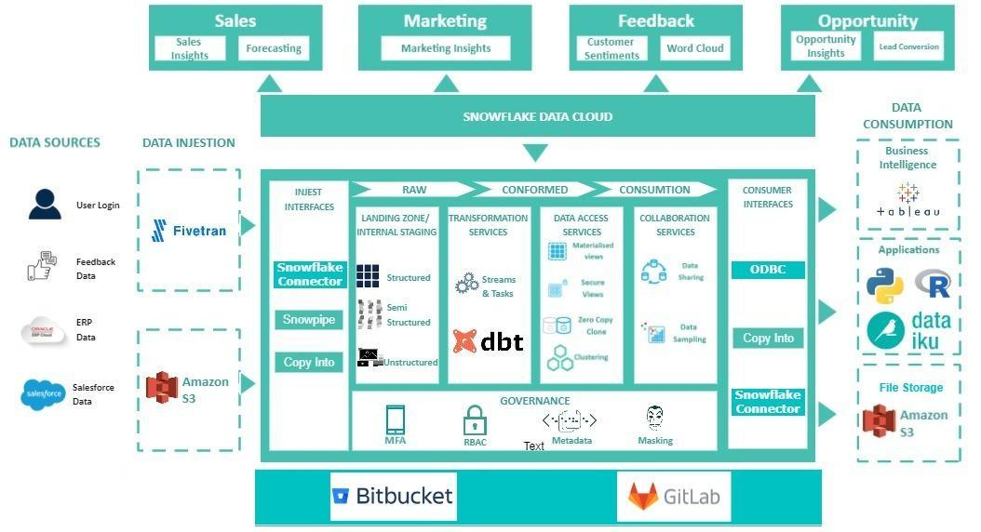

**Fig: Architectural Diagram for Medico Project**

## The above architectural diagram shows the overall flow of data from how it is getting dumped to Amazon S3 buckets to all the way to being used in various data applications for the client. The structure is as follows:

## The client dumps all the data from various sources into Amazon S3 buckets

## The data will then be ingested into Snowflake using Fivetran through three different methods based on the type of load viz., snowflake native connector, snowpipe & copy-into command

## An internal staging area is created with FIVETRAN_S3 schema for all types of data within Snowflake

## The data will then be loaded into DBT for making the necessary transformations to clean the data and make it available for creating views

## Other vital transformations will be executed in Snowflake using the features provided within

## Views are created in order to allow access for the required data to the respective tools via ODBC & native connectors

## Tableau takes the data into it by using the ODBC connector and create reporting dashboards

## Python, R & Dataiku will be using the native connector to load the data and make the machine learning models that provide analysis on various indicators

## The whole project will follow Agile methodology for which we are using Gitlab to process the CI/CD pipeline

## Bitbucket & Amazon S3 are used for data storage purposes for having the processed data at once place

* **Relevant Snowflake Features & Their Use Case**

| Feature | Use Case |
| --- | --- |
| Transient Tables | To store the transformations from DBT |
| Zero Copy Cloning | To transfer the data from data lake to data warehouse |
| Snowpipe | For continuous data loading |
| Streams | To capture the change in data |
| Tasks | To consume the streams & execute SQL queries |
| Data Masking | To hide sensitive data |
| Secure Views | To show view definitions & details only to authorized users |
| Materialized Views | To allow faster access & reduce computing cost |
| External Tables | To have file level metadata which allows querying data from an external stage |
| Data Sampling | To check the consistency of data to later feed it to ML models |
| Data sharing | To share files required to the reader account |
| Clustering | To help in query optimization & performance |
| Multi-factor Authentication | To provide better security while users access the warehouse |

**3.b Data Mapping**

Data mapping is the process of matching fields from one database to another. This helps in linking sensitive data or other data to its matching data resources when moving the data from one platform to another

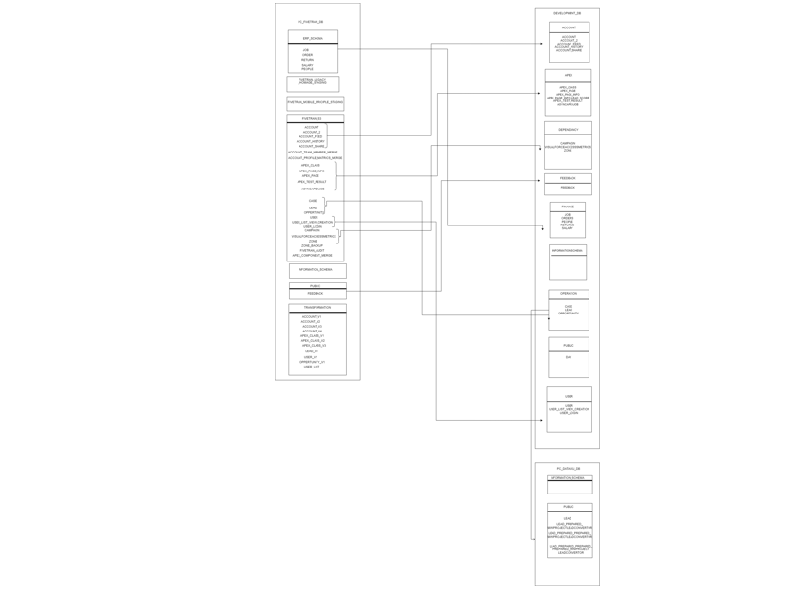

**3.c ER Diagram**

The entity relationship diagram is a graphical representation of relationships between people, objects & other accounts known as entities in a flow chart format. It will serve as a reference point throughout the organization. The following diagram shows the entity relationship between entities for CRM data

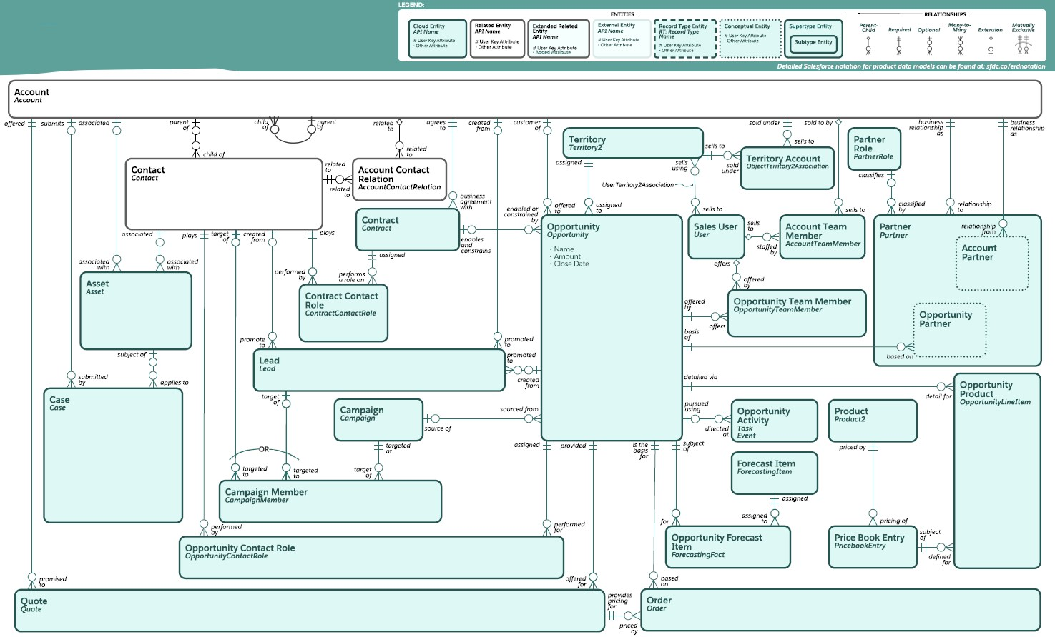

**3.d Data Definition**

The following screenshot will show gist of the data definition i.e., the description of columnar data of the files

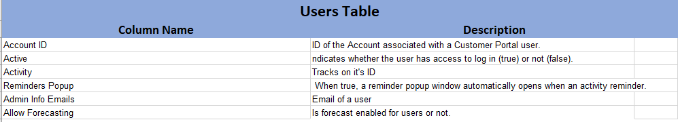

**4. DETAILED DESIGN**

**4.a WAREHOUSING**

**Snowflake Architecture**

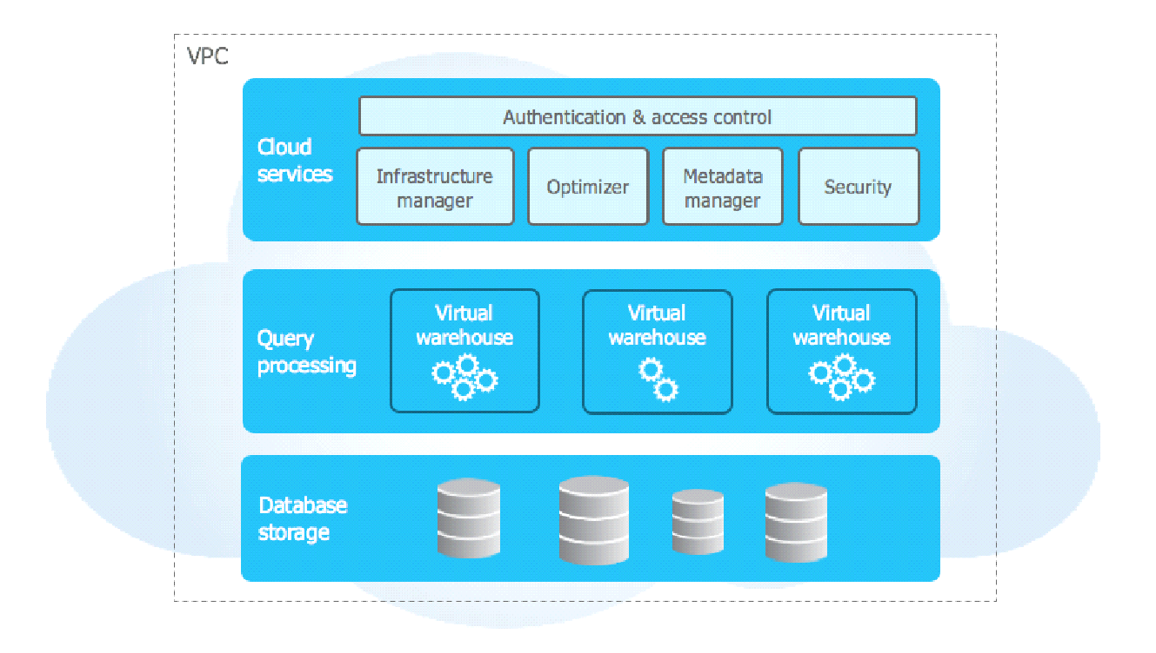

**Fig: Snowflake Architecture**

Snowflake’s architecture is a hybrid of traditional shared-disk and shared-nothing database architectures. This approach offers the data management simplicity of a shared-disk architecture, but with the performance and scale-out benefits of a shared-nothing architecture.

**Role Based Access Diagram**

Snowflake provides granular control over access to objects — who can access what objects, what operations can be performed on those objects, and who can create or alter access control policies.

Roles are the entities to which privileges on securable objects can be granted and revoked. Roles are assigned to users to allow them to perform actions required for business functions in their organization

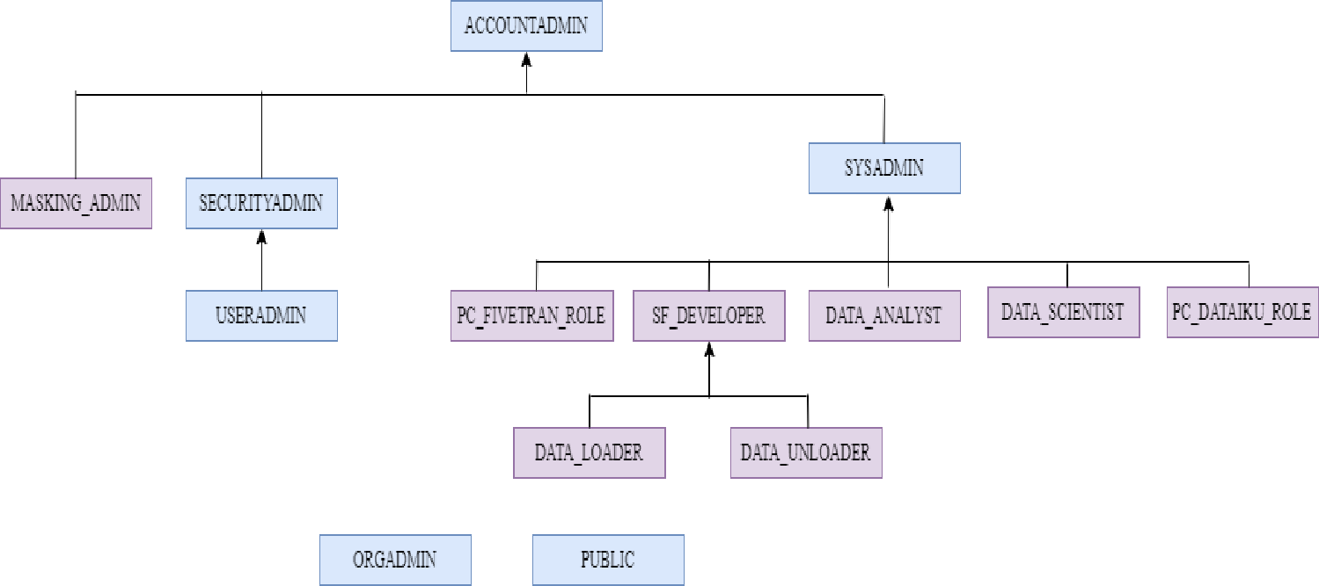

**Virtual Warehouse**

A virtual warehouse, often referred to simply as a “warehouse”, is a cluster of compute resources in Snowflake. In this project for every custom role individual warehouses have been created.

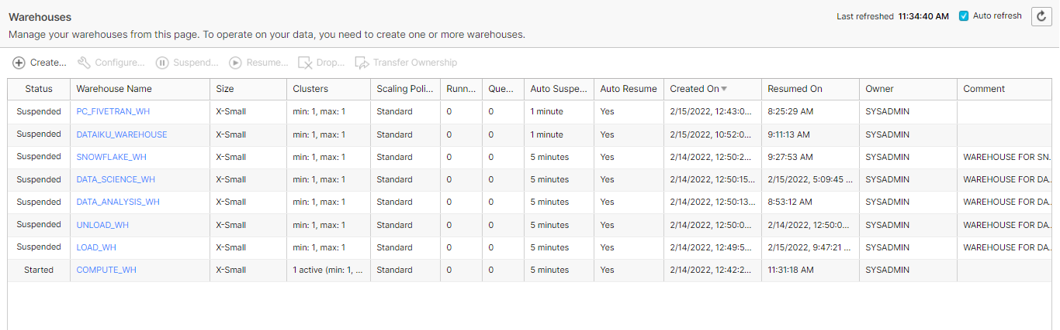

**Resource Monitor**

To help control costs and avoid unexpected credit usage caused by running warehouses, Snowflake provides *resource monitors*. A virtual warehouse consumes Snowflake credits while it runs.

Resource monitors can be used to monitor credit usage by user-managed virtual warehouses and virtual warehouses used by cloud services. A resource monitor can suspend user-managed warehouses based on credit usage thresholds.

All the created warehouses in the snowflake instances have been attached to resource monitors.

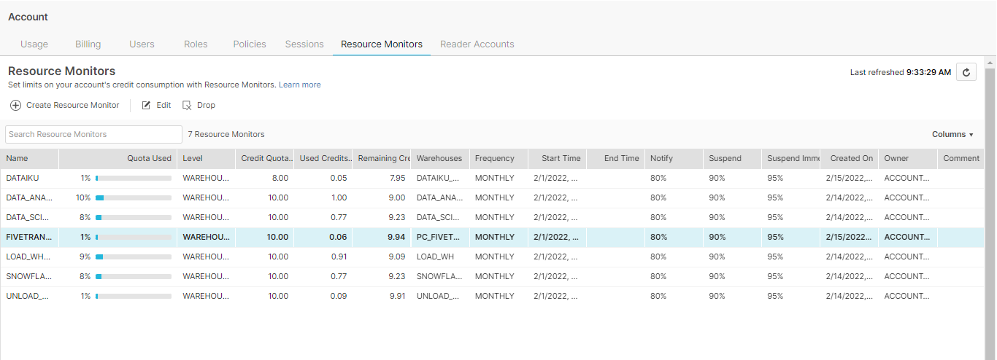

**4.b REPORTING**

**Tableau Architecture**

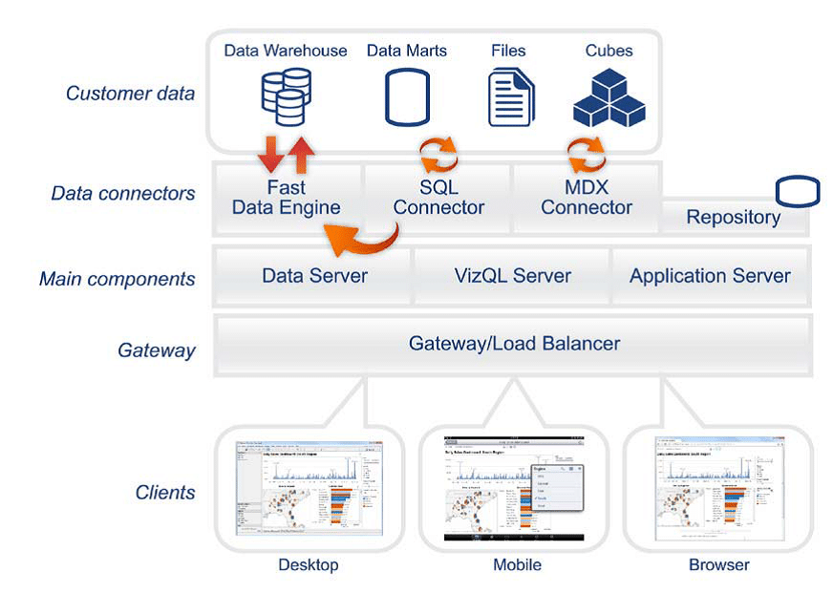

Tableau can connect to multiple data sources remotely, be it an excel file, a web application or a database. We connect tableau to snowflake using Snowflake provided ODBC connector from the “help” connection within the snowflake instance. Data Engine stores the tableau data extract which is pooled from various data sources. Data Engine responses to any visualization that has been created using the tableau data extract.

The gateway, using the application server for authentication process will forward the login request to the server. When the authenticity is verified, it returns with the database we have requested access for along with the type of schema & warehouse based on the type of data source we are trying to connect.

**4.c MACHINE LEARNING**

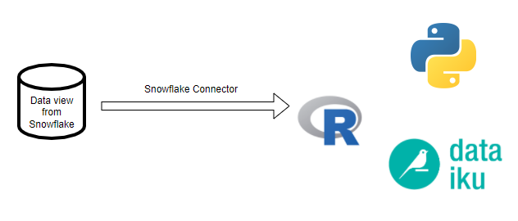

**Fig: Connection from Snowflake to ML tools**

Machine learning is a subfield of artificial intelligence, which is broadly defined as the capability of a machine to imitate intelligent human behavior.

The views created in snowflake from the transformed data are loaded into three tools i.e., Python, Dataiku & R. These data views are classified into train data and test data. The models were created based on training the data and adding the results. Various tools mentioned above are used for achieving certain outcomes varying from sentiment analysis to word cloud.

We are using some modules :-

* NLP :- Natural language Processing i.e. used for sentiment analysis
* Sklearn :- Scikit learn library is an ML algorithm used for classification , regression and clustering.

Creating some models in Sentiment Analysis :- We will select the best one with highest accuracy

* Logistic Regression
* Decision Tree
* KNN i.e. kth nearest neighbor
* SVC i.e. Support Vector Classifier
* Naive Bayes Algorithm

Models in Dataiku :- We will select the best model for our production

* Random Forest
* Logistic Regression

**5. IMPLEMENTATION & TESTING**

**5.a Data Ingestion using Fivetran**

* With the help of Fivetran, we are making connections between S3 bucket and Snowflake for data ingestion. Setting up Fivetran warehouse, role, user and database for connection

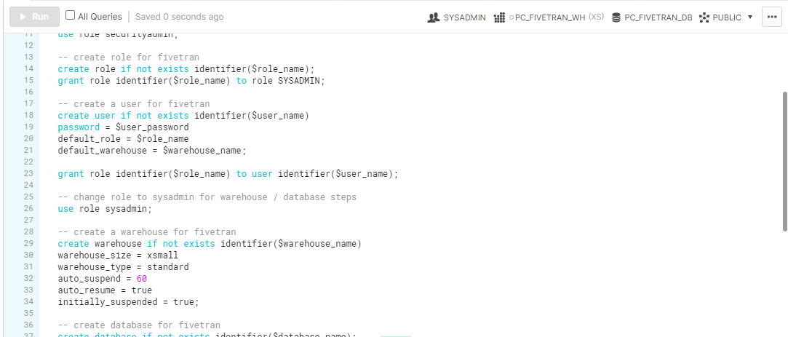

* Completing setting up fivetran environment in Snowflake

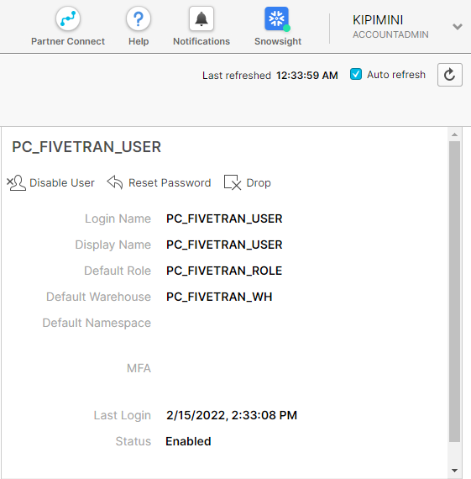

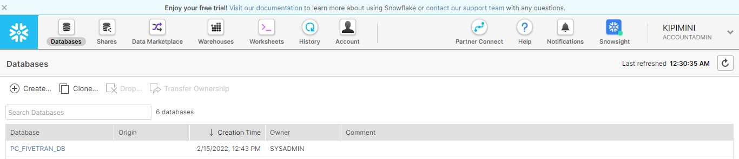

* For each table, connectors have been made in fivetran to load the data into Snowflake.

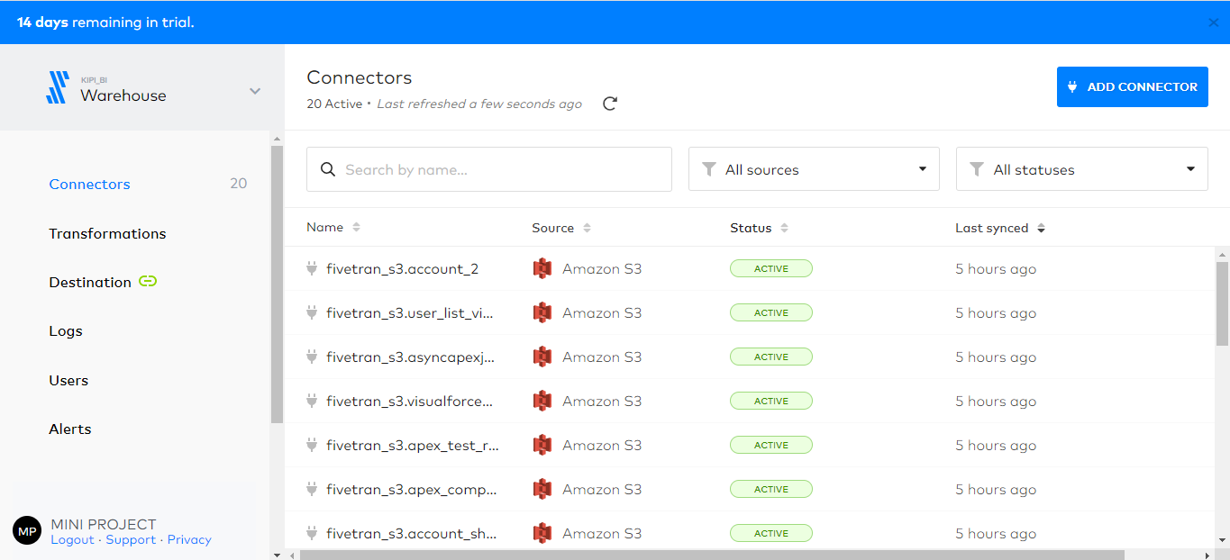

**5.b Data loading using Snowpipe:**

* Lambda function for stimulation of file from source bucket to destination bucket

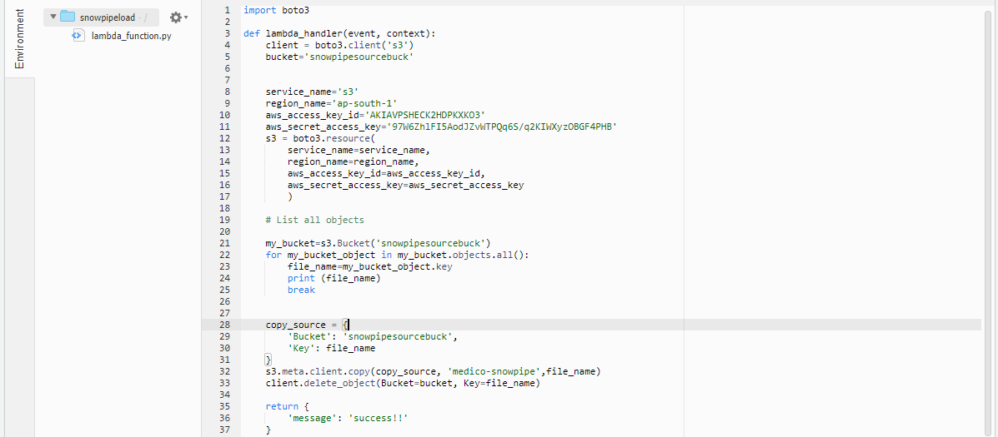

* Here lambda function will fetch file from the source bucket and insert it into the destination bucket

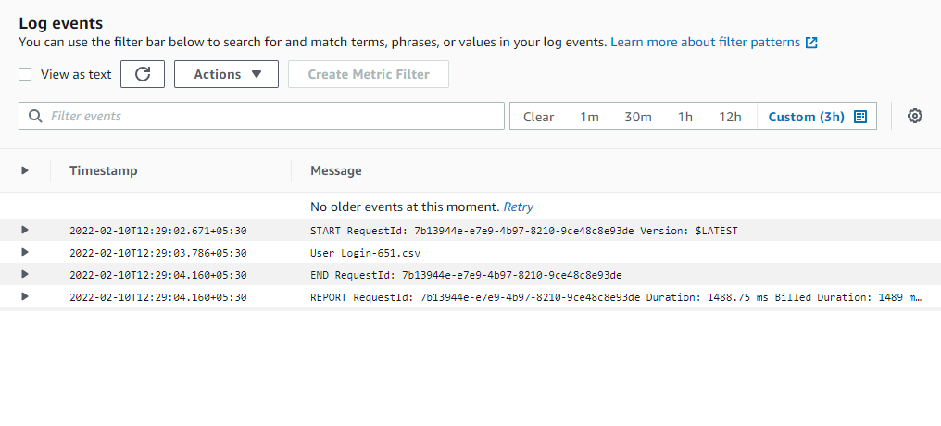

* Now that file gets loaded to snowflake through snowpipe

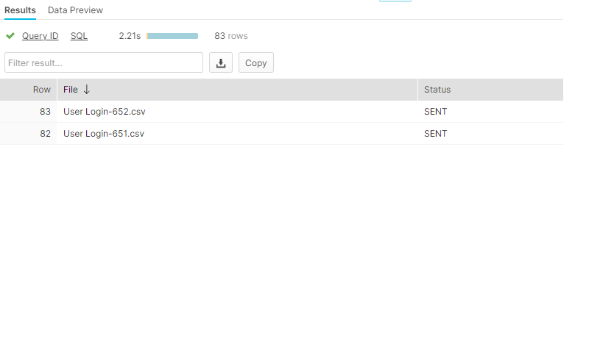

* Data in user login table

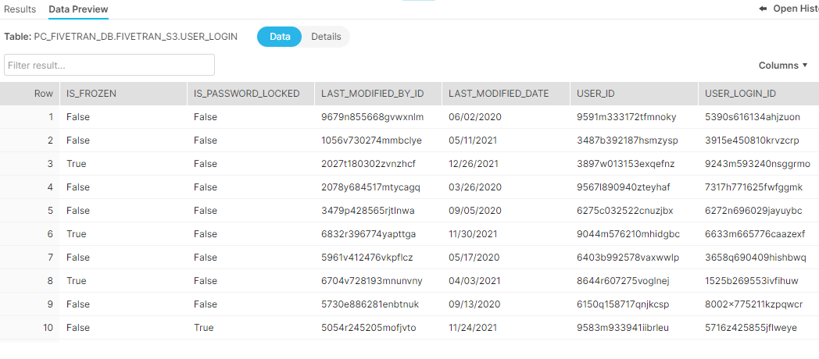

* Pipe status

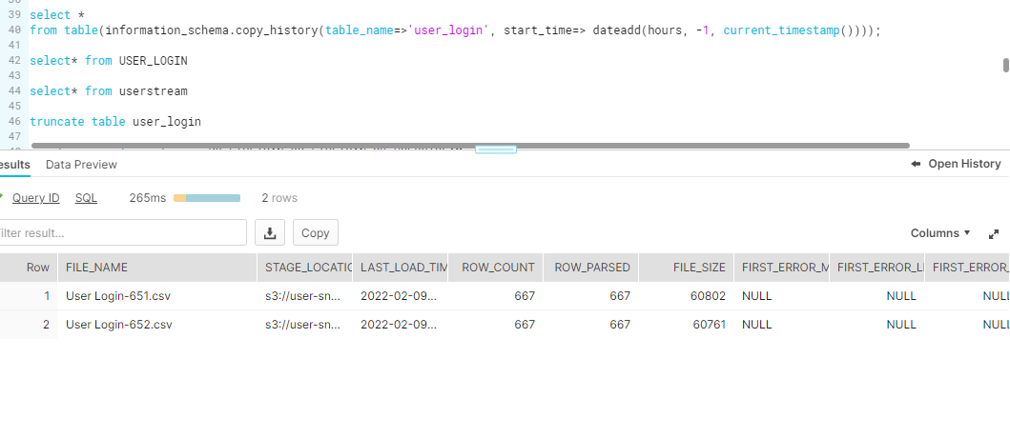

* Task status

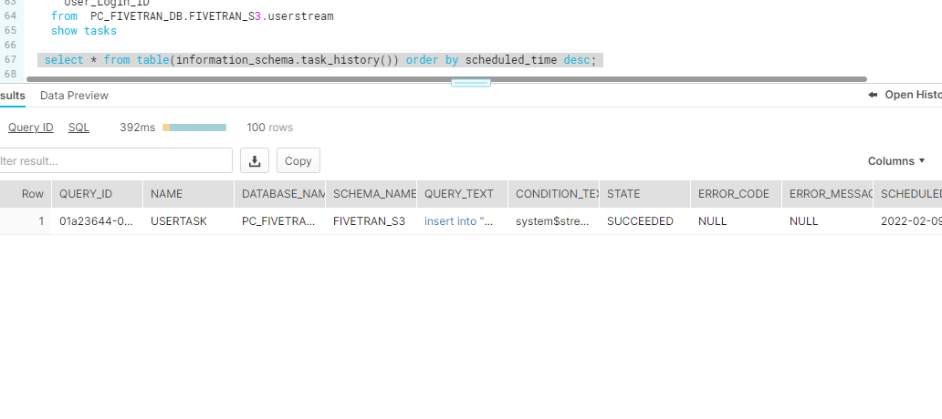

* Data in user login after task has fetched important columns from stream

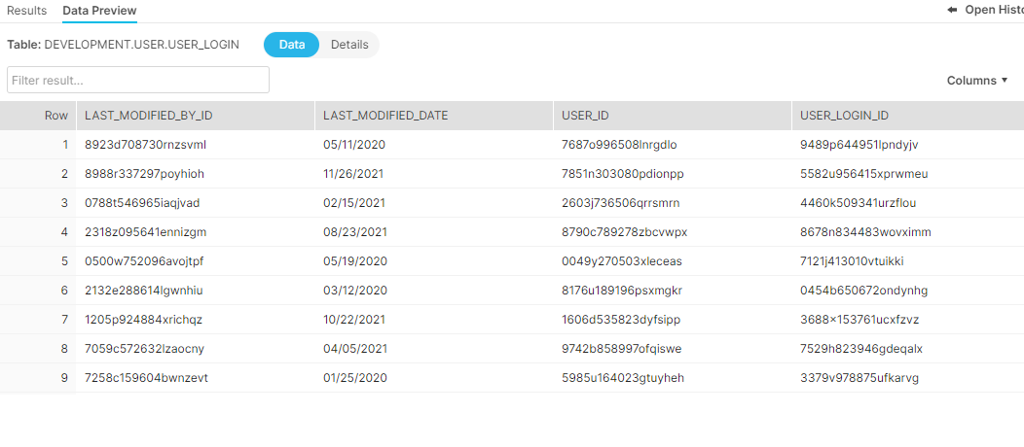

**5.c DBT Transformations**

DBT core is used for performing transformation as it is open source, and it has been connected with the GITLAB repository as well. The destination for DBT transformed tables and views is TRANSFORMATION schema in Data Lake PC_FIVETRAN_DB. Six tables are transformed using DBT, for 6 six models created generic test cases are created.

* DBT transformation model applied on table account

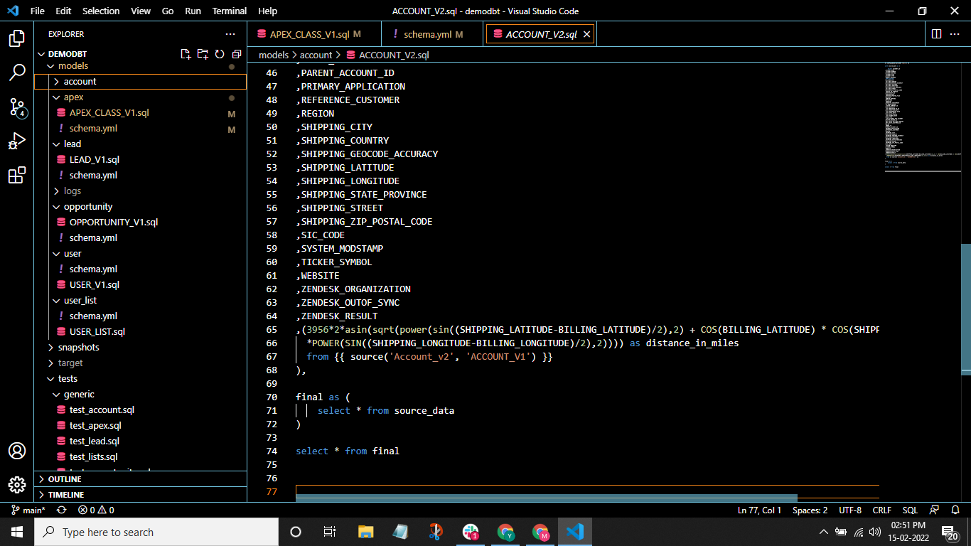

* generic test case to validate the model

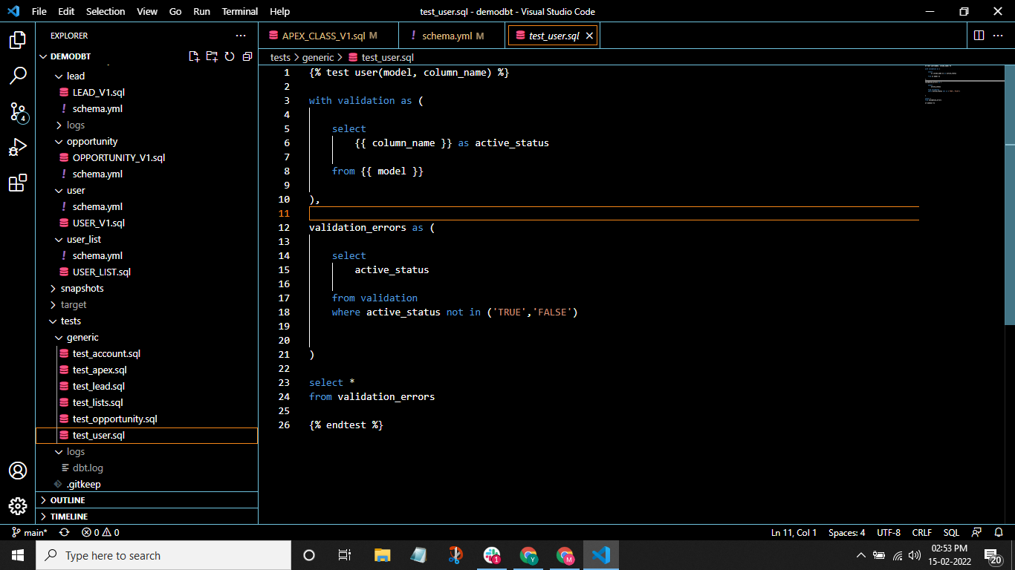

**GITLAB**

To store the codes written for transformation in DBT we are using GITLAB. We have connected DBT core to a private GITLAB repository and all the scripts for transformation and testing are pushed to GITLAB.

These are the files which are pushed to GITLAB.

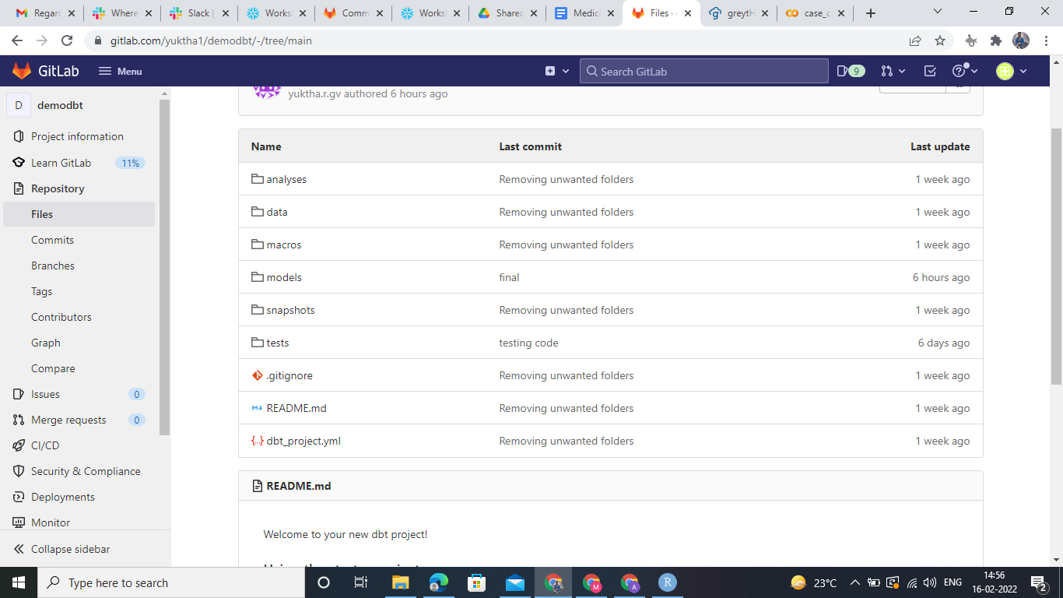

These are few commits done on the repository.

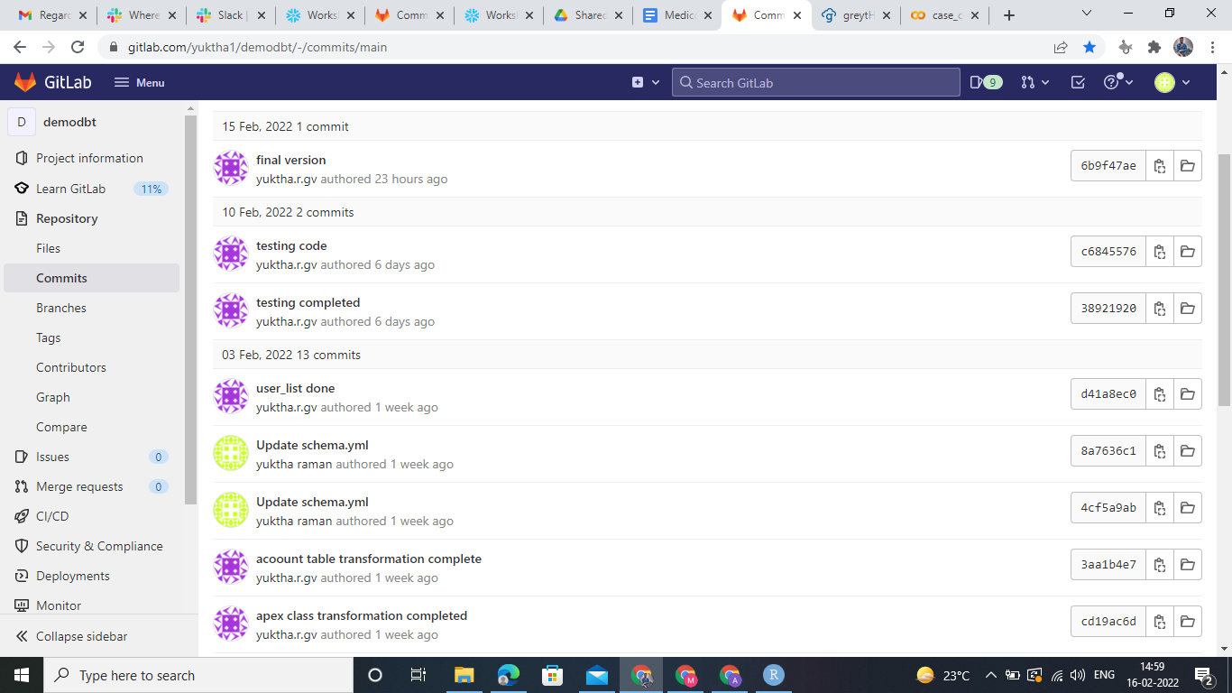

**5.d Snowflake Development**

* **Zero-copy Cloning**

A clone is writable and is independent of its source (i.e. changes made to the source or clone are not reflected in the other object).Parameters that are explicitly set on a source database, schema, or table are retained in any clones created from the source container or child objects.

We have used the zero copy cloning feature of snowflake to transfer our data from our data lake PC_FIVETRAN_DB to data warehouse DEVELOPMENT.

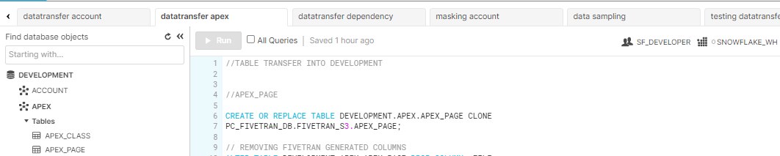

* **Data Masking**

Data masking is a version of your organizational data in a confidential manner. The goal is to protect sensitive data, while providing a functional alternative when real data is not needed. The following are the code snippets of data masking used

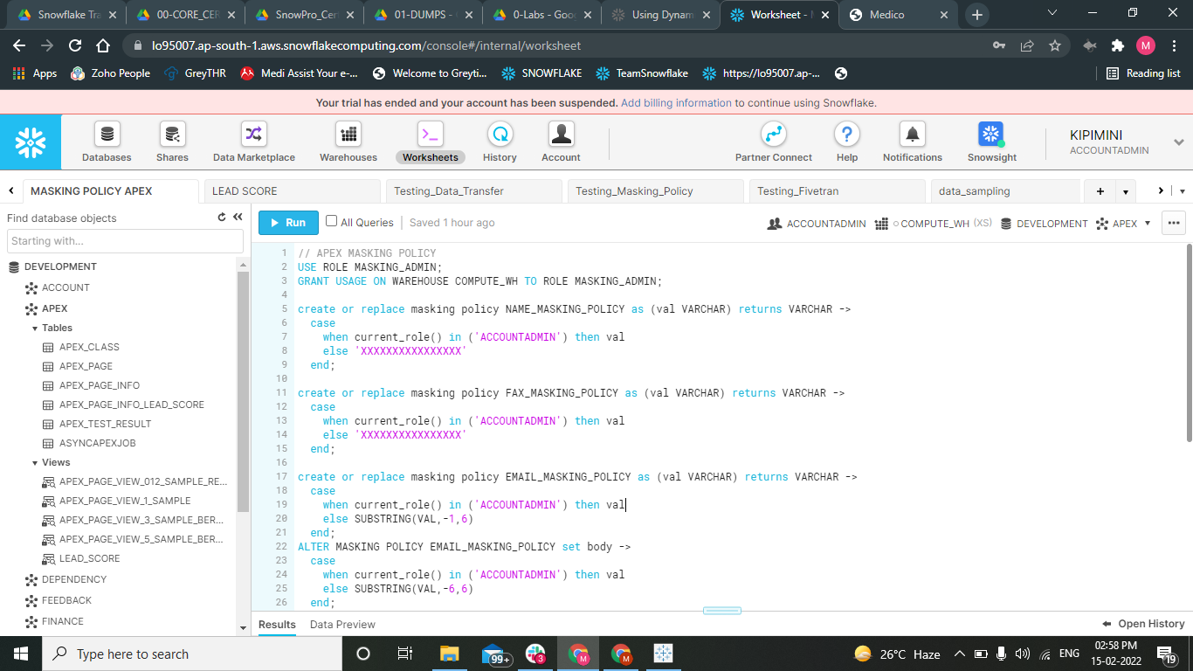

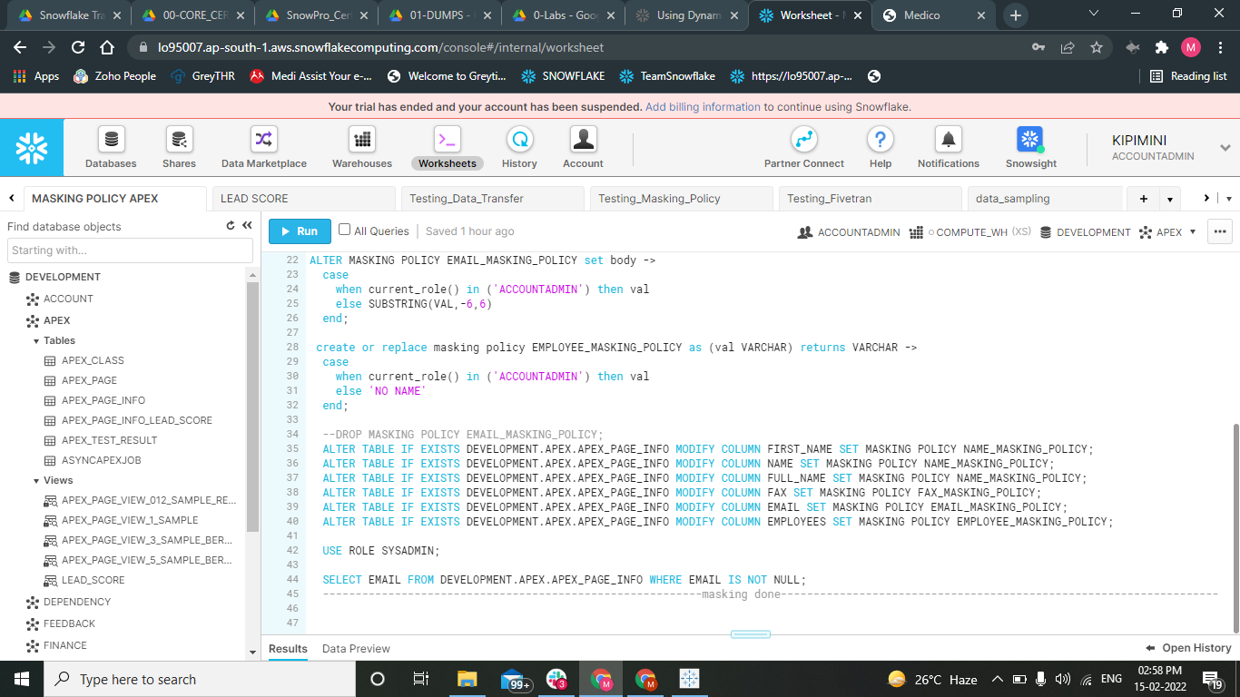

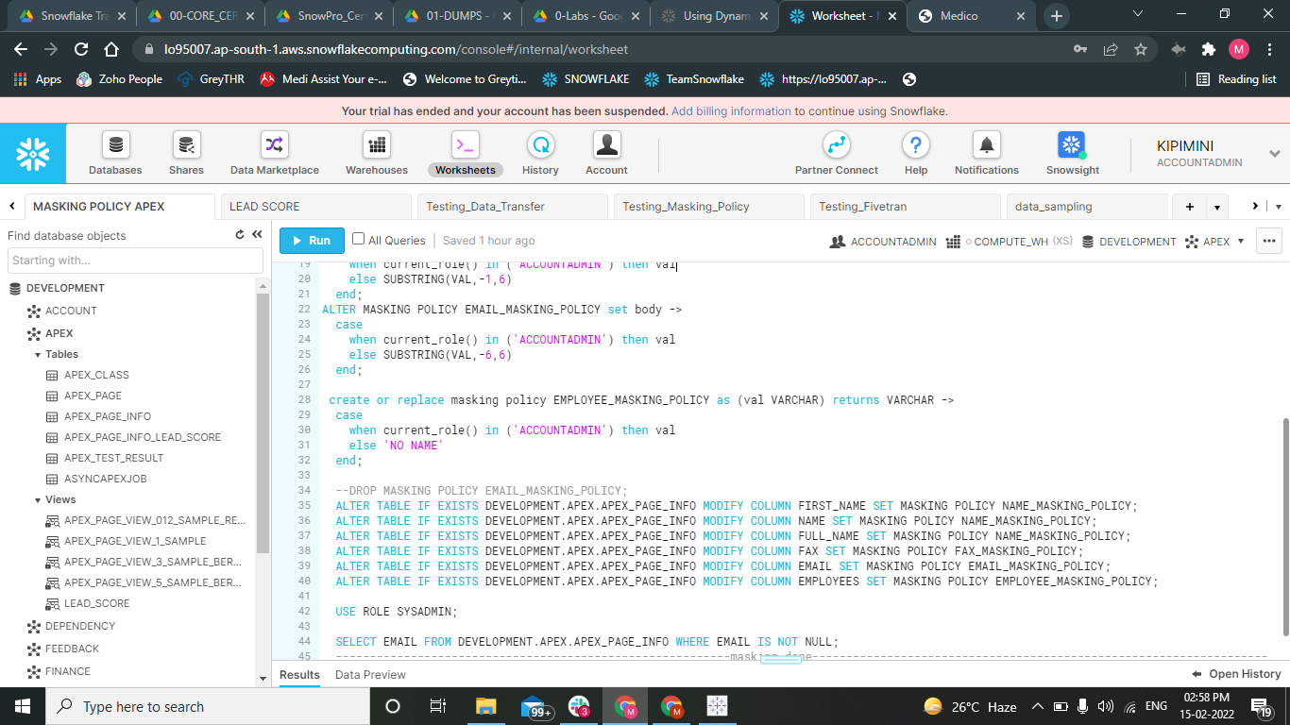

**5.e Views and table**

A view allows the result of a query to be accessed as if it were a table. The query is specified in the Standard View

In our snowflake instance we are using

* Secure views

For security or privacy reasons, we wish not to expose the underlying tables or internal structural details for a view. With secure views, the view definition and details are only visible to authorized users

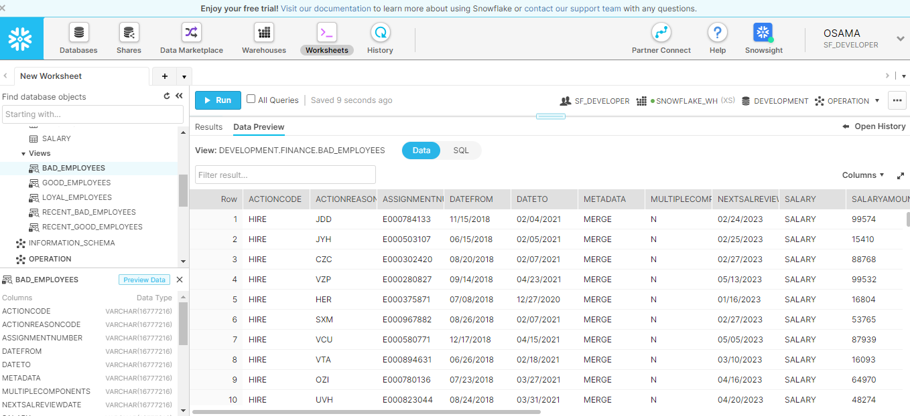

* **Materialized views**

A materialized view’s results are stored, almost as though the results were a table. This allows faster access, but requires storage space and active maintenance, both of which incur additional costs.

We have used materialized view for faster access and to provide cost savings

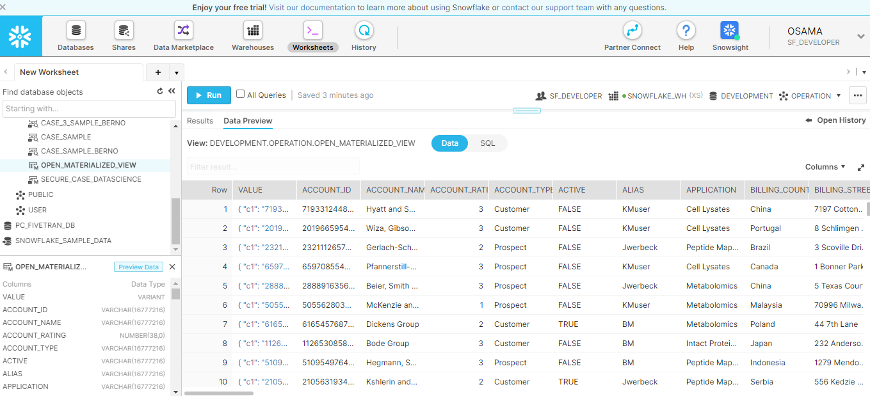

* **Secure Materialized views**

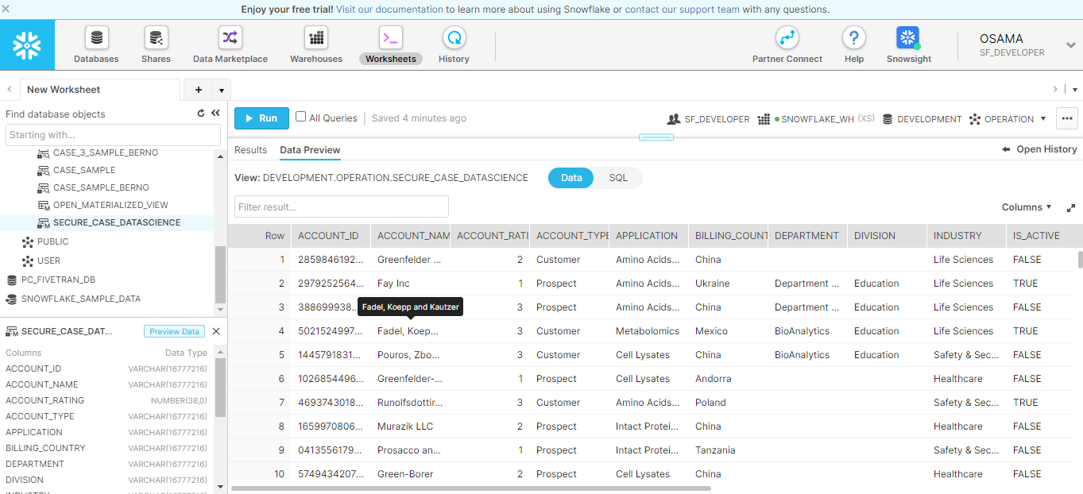

**Tables**

All data in Snowflake is stored in database tables, logically structured as collections of columns and rows.

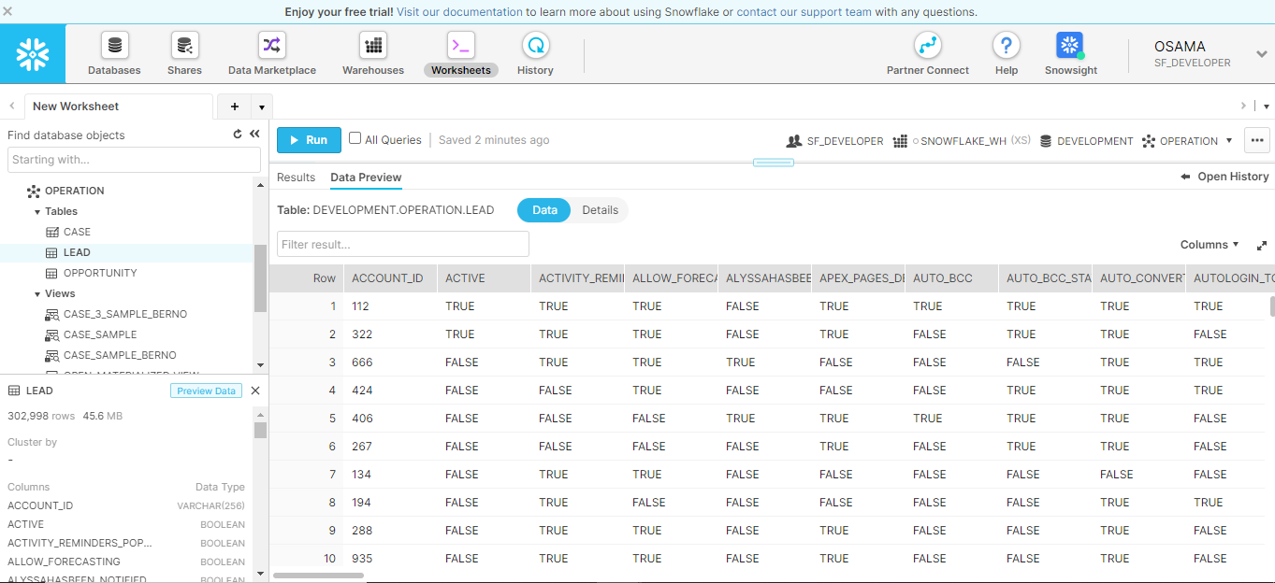

**External Table**

In a typical table, the data is stored in the database; however, in an external table, the data is stored in files in an external stage. External tables store file-level metadata about the data files, such as the filename, a version identifier and related properties. This enables querying data stored in files in an external stage as if it were inside a database.

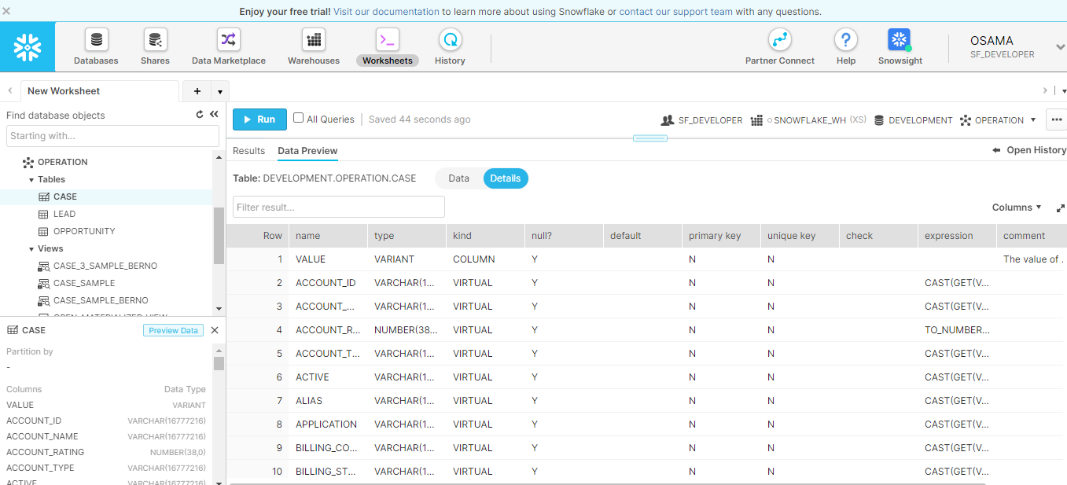

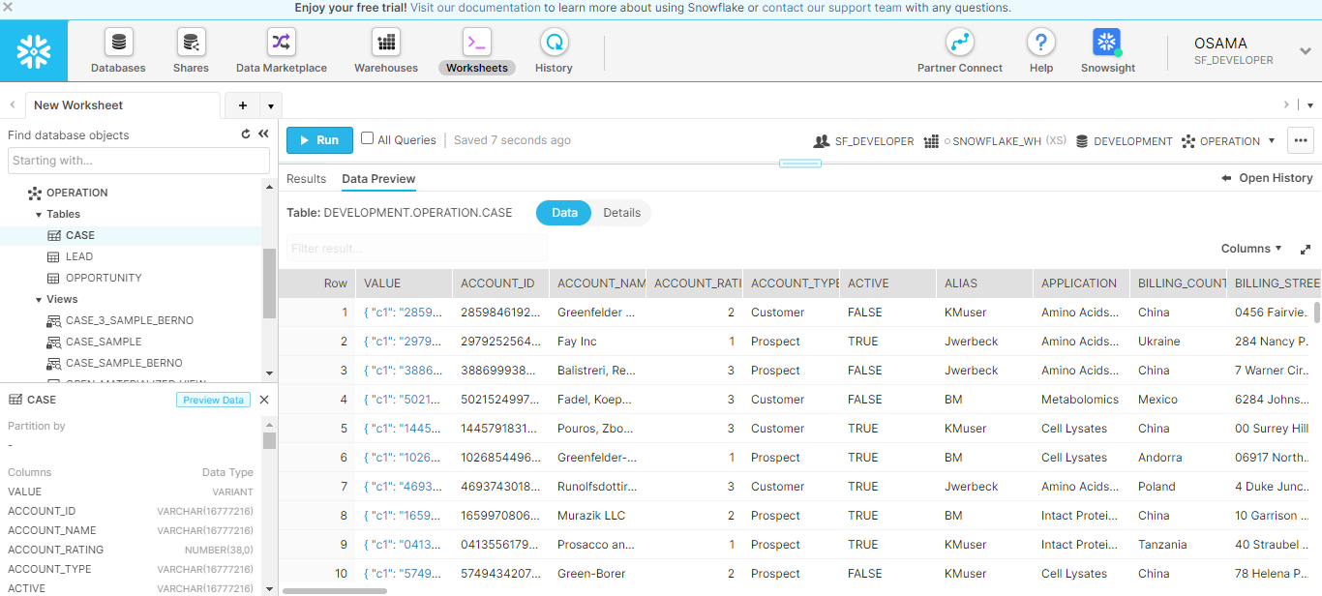

**Transient Table**

Transient tables are similar to permanent tables with the key difference that they do not have a Fail-safe period.

Transient tables are specifically designed for transitory data that needs to be maintained beyond each session enable

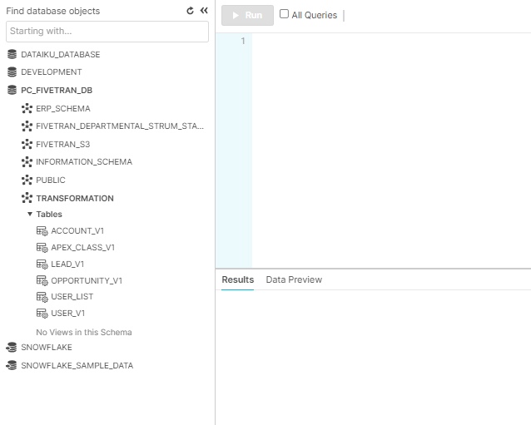

**5.f Data Sampling & Secure Data Sharing**

**Data Sampling -** In data sampling, here we are creating three data samples either by randomly selecting rows or randomly selecting blocks of data (based on the micropartition schema adopted by snowflake) and in the sampling method we are using Bernoulli and System method for our case table to check the consistency of the data which will be further used by machine learning models.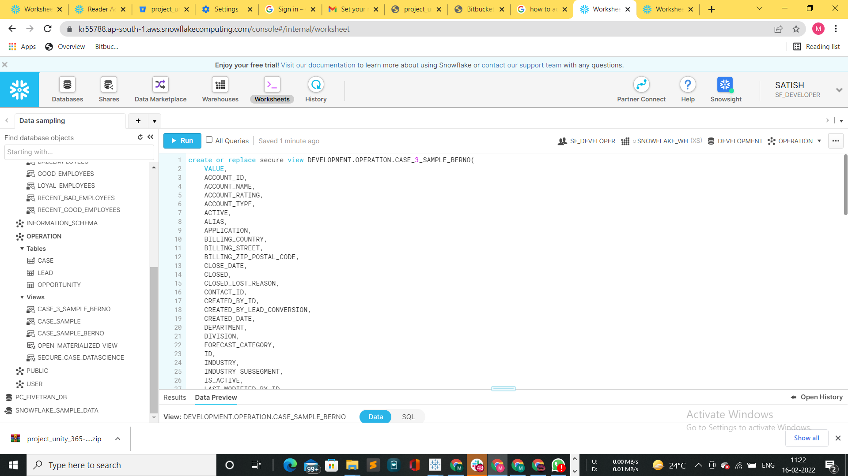

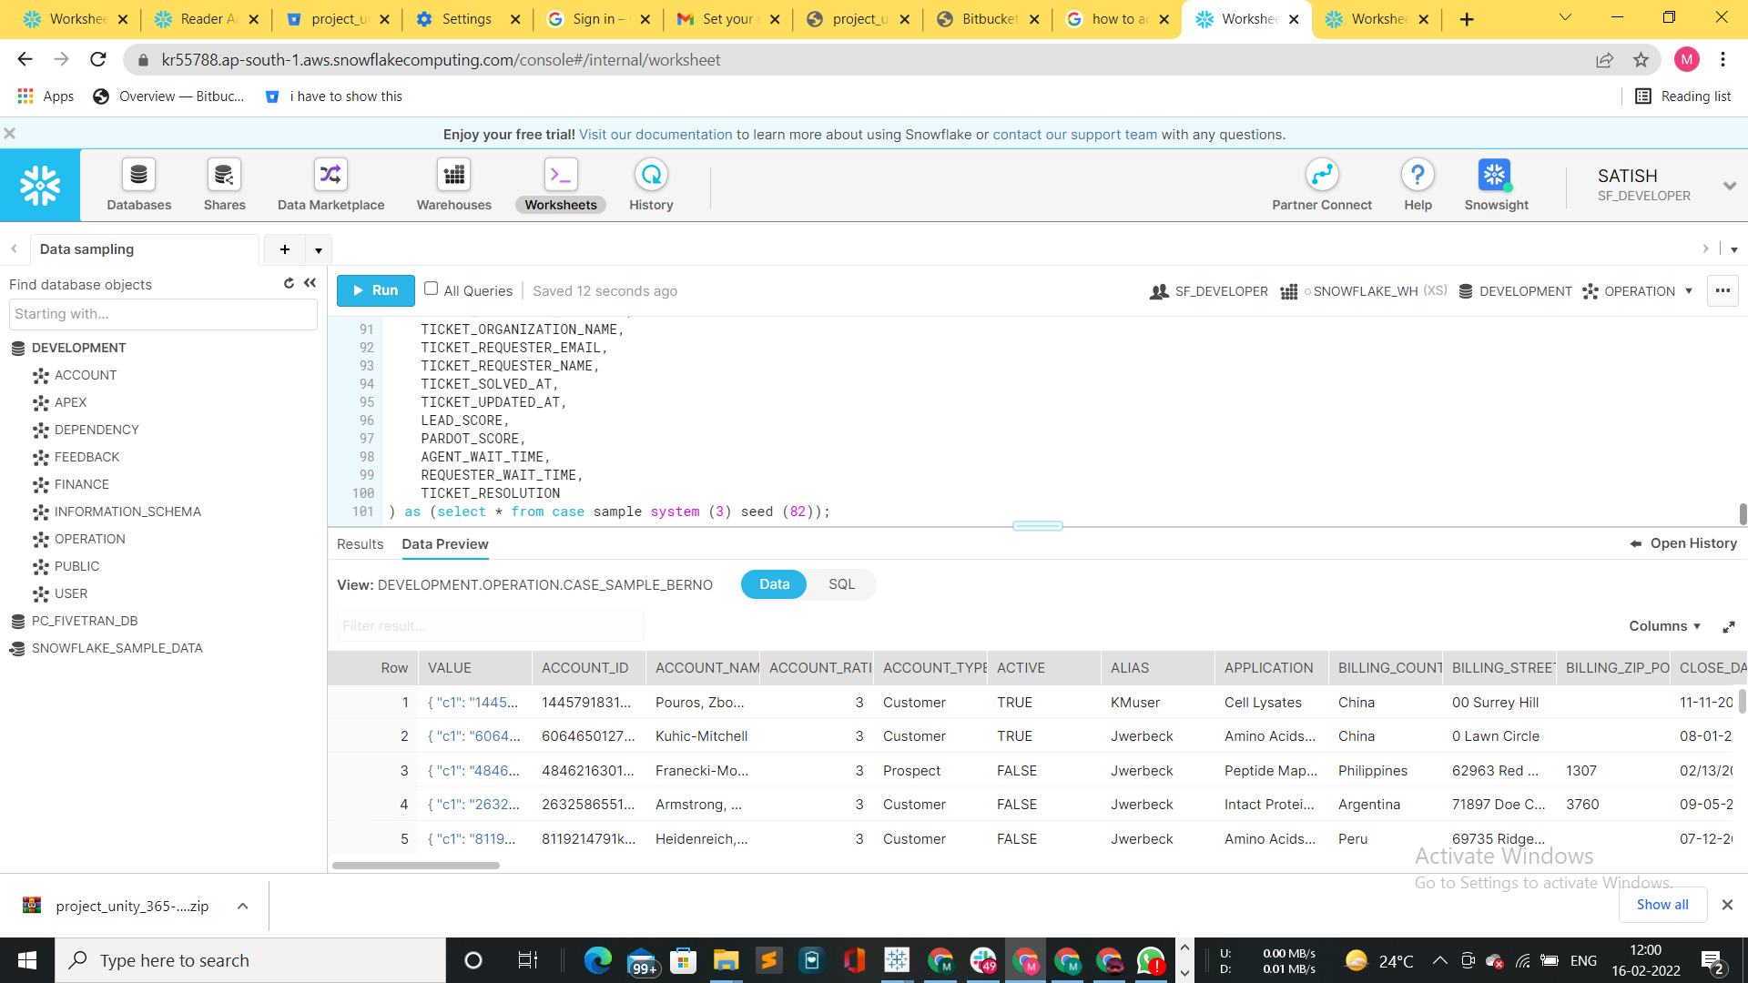

**Secure Data Sharing -** Here we are creating a reader account for our client Medico and giving access to the Medico HR Team. And for that we are creating an outbound share for Medico HR and sharing the secure views i.e. employee details like: BAD_EMPLOYEES, GOOD_EMPLOYEES, etc. Which will be further used by their HR team.

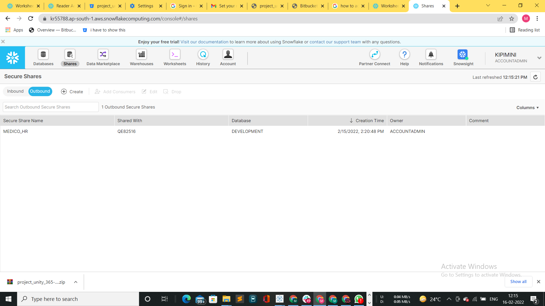

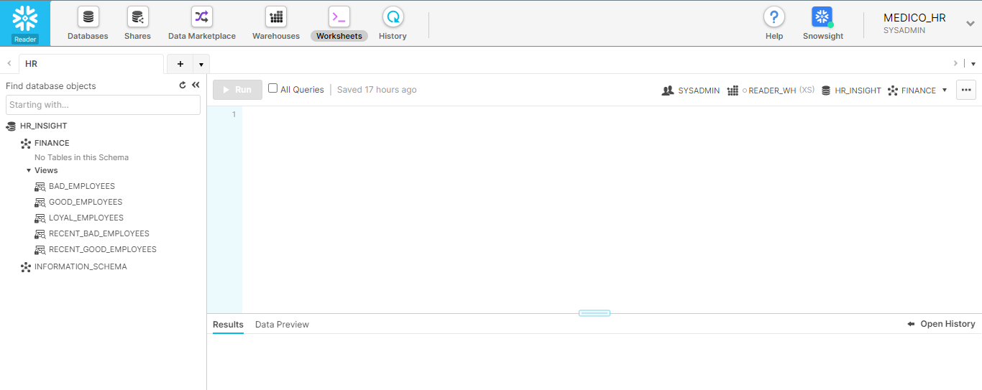

**5.g Query optimization, performance monitoring & Metadata**

**Clustering**

Snowflake produces well-clustered data in tables; however, over time, particularly as DML occurs on very large tables the data in some table rows might no longer cluster optimally on desired dimensions.

To improve the clustering of the underlying table micro-partitions, you can always manually sort rows on key table columns and re-insert them into the table; however, performing these tasks could be cumbersome and expensive. Instead, Snowflake supports automating these tasks by designating one or more table columns/expressions as a *clustering key* for the table. A table with a clustering key defined is considered to be *clustered*. You can cluster [materialized views](https://docs.snowflake.com/en/user-guide/views-materialized.html), as well as tables. The rules for clustering tables and materialized views are generally the same.

We have performed clustering on tables like ACCOUNT_2, ACCOUNT_FEED, APEX_PAGE, ZONE, APEX_PAGE_INFO, CAMPAIGN, VISUALFORCE ACCESS METRICS etc.

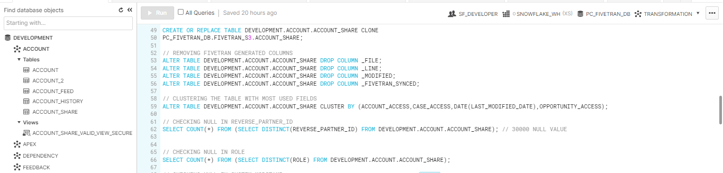

**5.h Security in Snowflake**

Snowflake supports multi-factor authentication (i.e. MFA) to provide increased login security for users connecting to Snowflake. MFA support is provided as an integrated Snowflake feature, powered by the [Duo Security](http://www.duosecurity.com/) service, which is managed completely by Snowflake.

Users do not need to separately sign up with Duo or perform any tasks, other than installing the Duo Mobile application, which is supported on multiple smartphone platforms. MFA is enabled on a per-user basis; however, at this time, users are not automatically enrolled in MFA. To use MFA, users must enroll themselves.

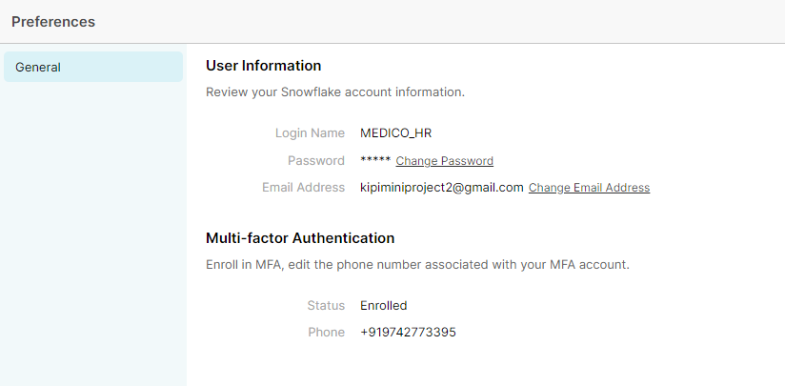

**5.i Data Unloading**

Snowflake supports bulk export (i.e. unload) of data from a database table into flat, delimited text files.We have unloaded the feedback data to AWS S3 for further analysis of the data.

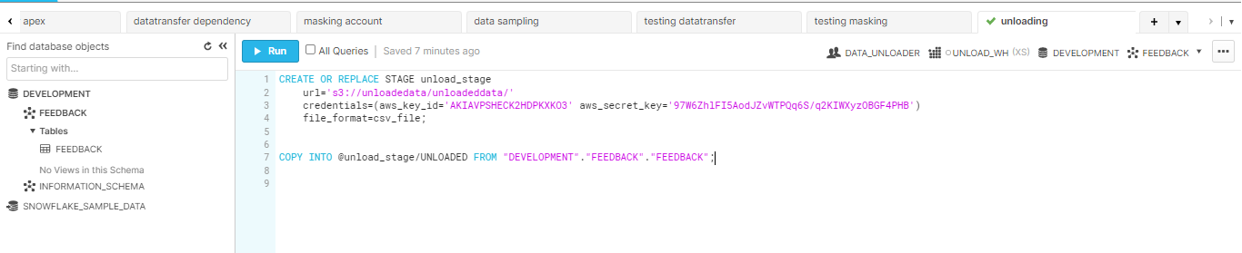

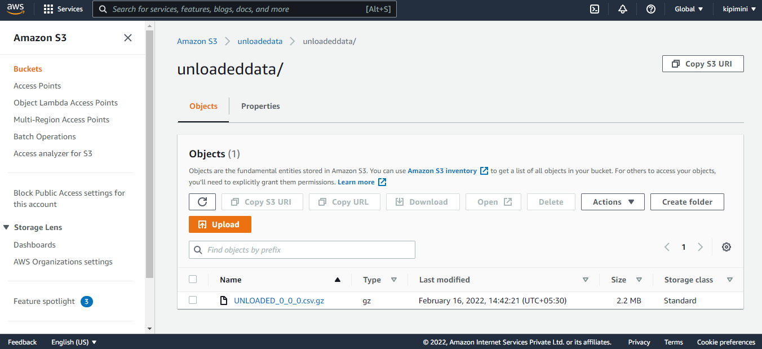

**5.j Testing Snowflake Tables**

The following screenshots show the test scripts for whether the tables loaded into snowflake are having the exact data from the source taken with respect to number of rows & columns etc.,

Testing number of rows and columns of following tables: FEEDBACK, CAMPAIGN, APEX TEST RESULT, ACCOUNT HISTORY

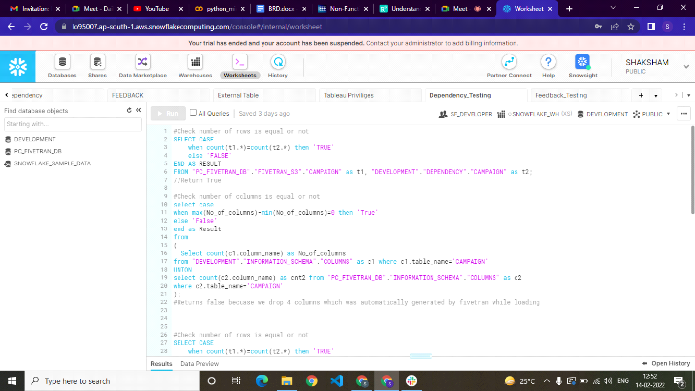

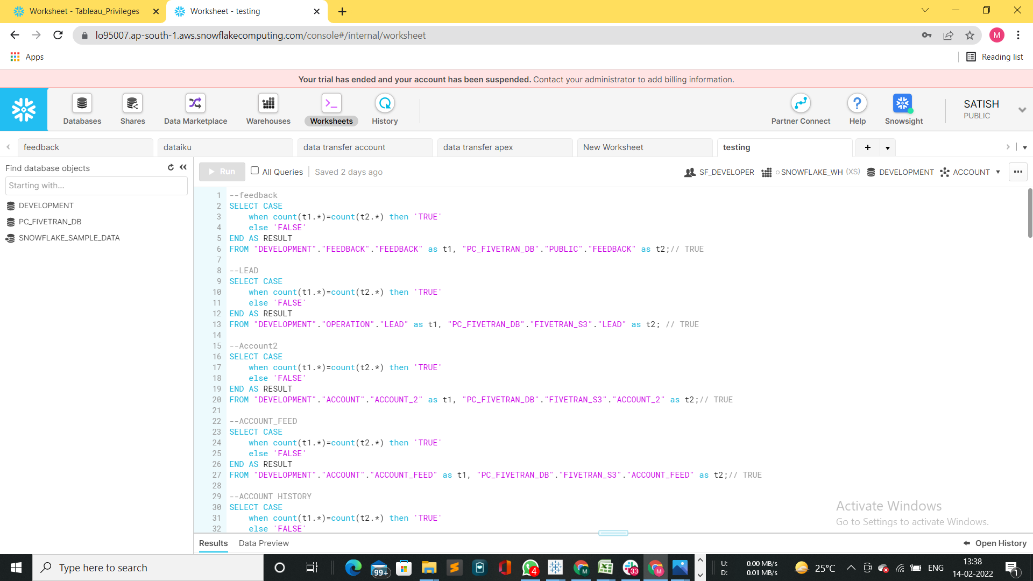

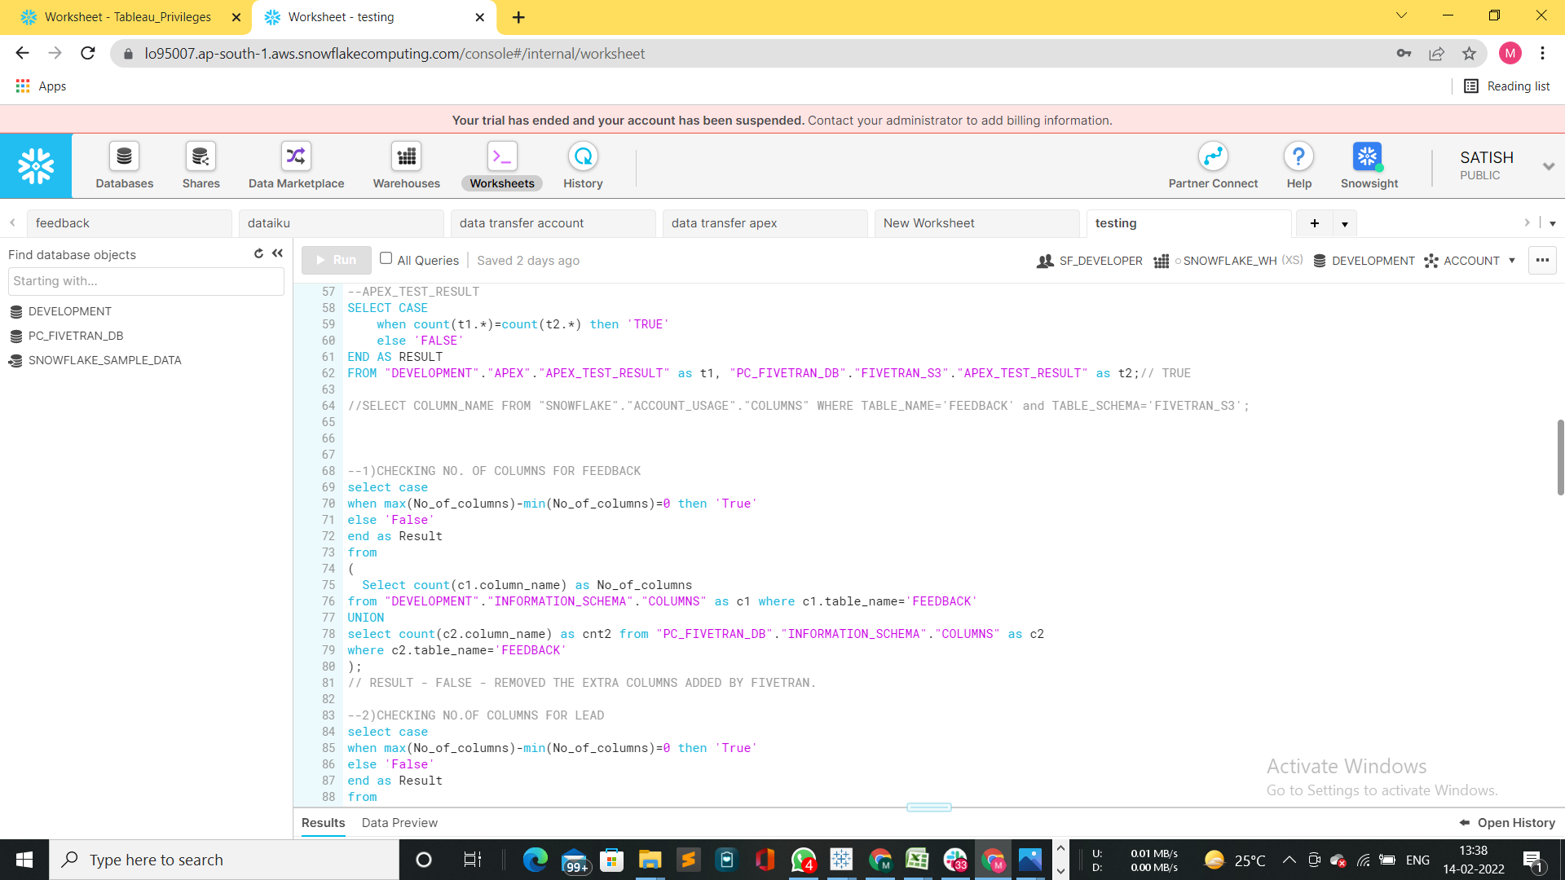

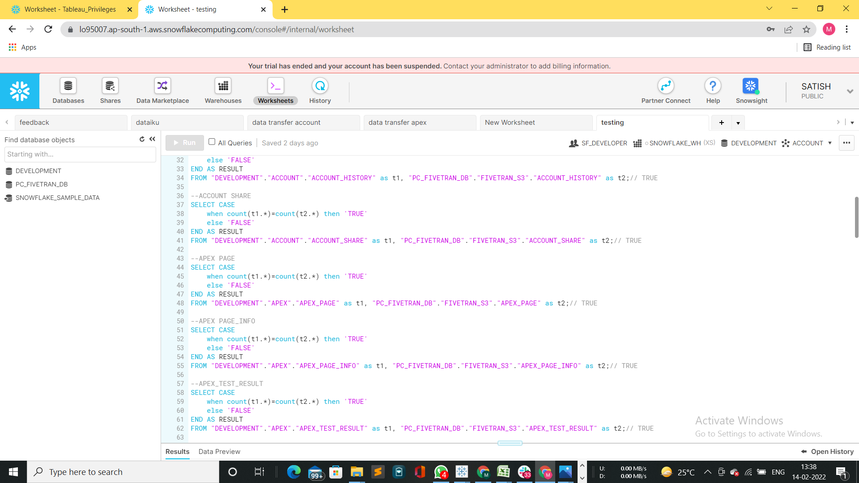

* **Test Case Tables**

The following is the test case table for the same:

| **TEST CASE ID** | **TEST CASE NAME** | **TEST CASE DESCRIPTION** | **RESULT** |
| --- | --- | --- | --- |
| TO1 | SNOWPIPE | TEST CASE TO CHECK IF THE DATA LOADED IN SNOWFLAKE IS CORRECT | PASS |
| TO2 | TESTING OF LOADED DATA TABLES | VISUAL FOR ACCESS METRICS | PASS |
| TO3 | TESTING OF LOADED DATA TABLES | CAMPAIGN | PASS |
| TO4 | TESTING OF LOADED DATA TABLES | FEEDBACK | PASS |
| TO5 | TESTING OF LOADED DATA TABLES | ZONE | PASS |
| TO6 | TESTING OF LOADED DATA TABLES | ACCOUNT_HISTORY | FAIL |
| TO7 | TESTING OF LOADED DATA TABLES | ACCOUNT_2 | FAIL |
| TO8 | TESTING OF LOADED DATA TABLES | ACCOUNT_FEED | FAIL |
| TO9 | TESTING OF LOADED DATA TABLES | ACCOUNT_SHARE | FAIL |
| TO10 | TESTING OF LOADED DATA TABLES | APEX_PAGE | FAIL |
| TO11 | TESTING OF LOADED DATA TABLES | ASYNCAPEXJOB | FAIL |
| TO12 | TESTING OF LOADED DATA TABLES | APEX_TEST_RESULT | FAIL |
| TO12 | TESTING OF LOADED DATA TABLES | APEX_PAGE_INFO | FAIL |

**5.k Tableau**

**Wireframe creation**

Using Figma, we are able to understand and design the three dashboards i.e., Opportunity, Pipeline & ERP ones. The following are the wireframes designed before starting the development of dashboards.

* **Opportunity Wireframe**

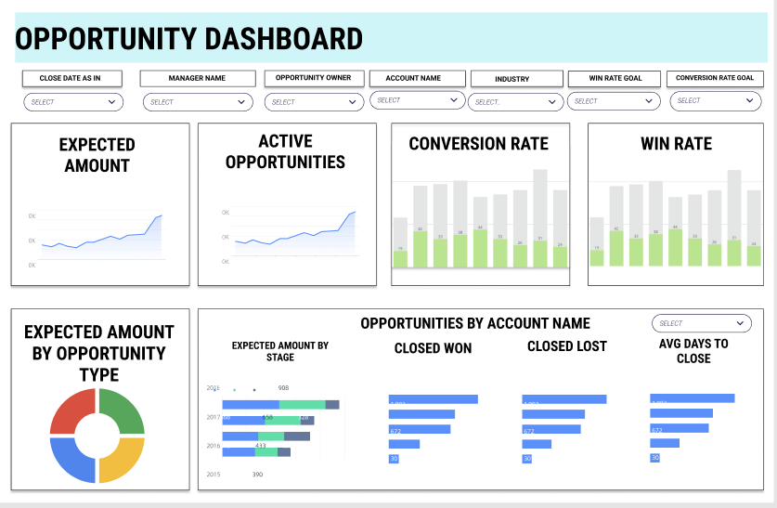

* **Pipeline Wireframe**

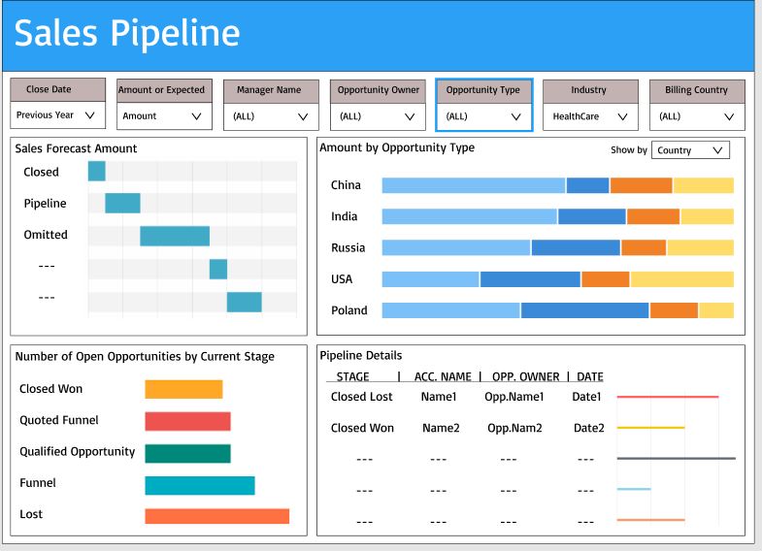

* **ERP wireframe**

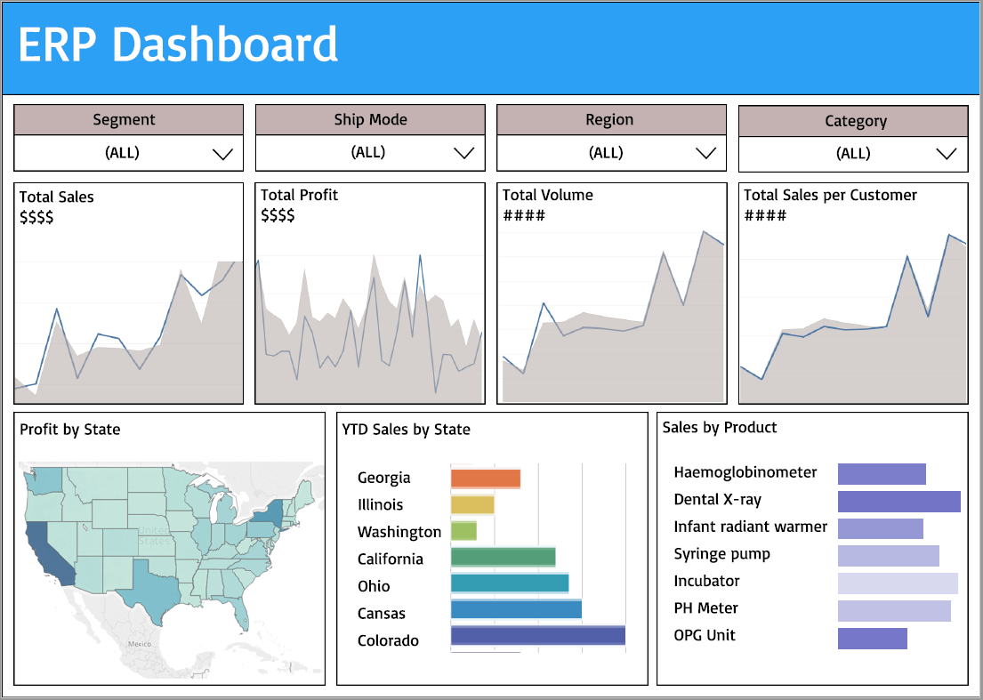

**Dashboards creation**

* **Snowflake usage Dashboard**

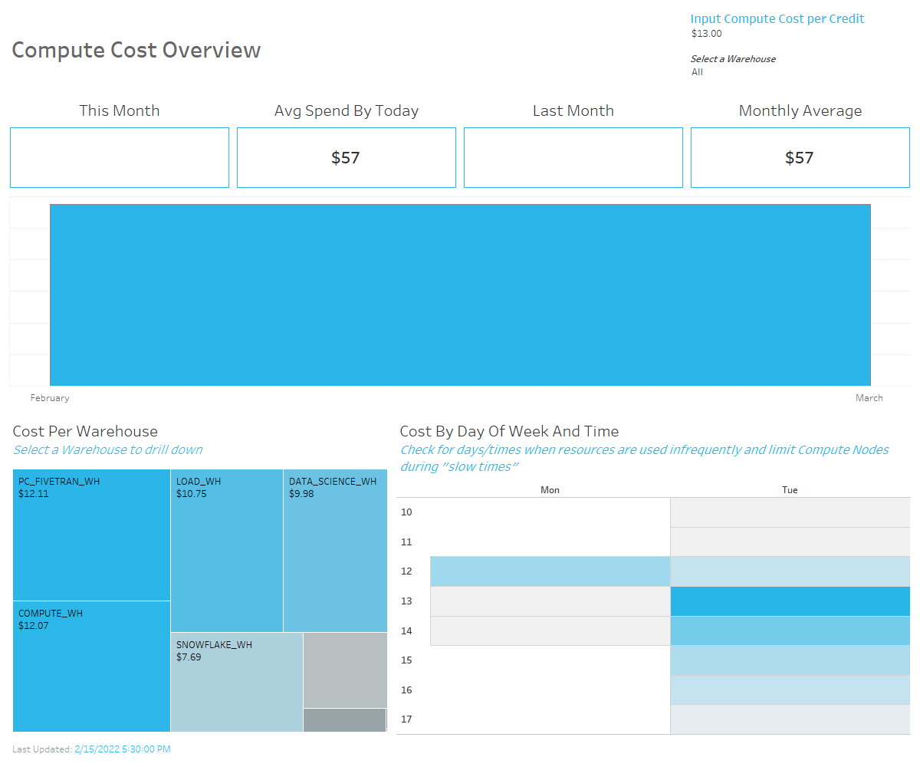

* **Opportunity Dashboard**

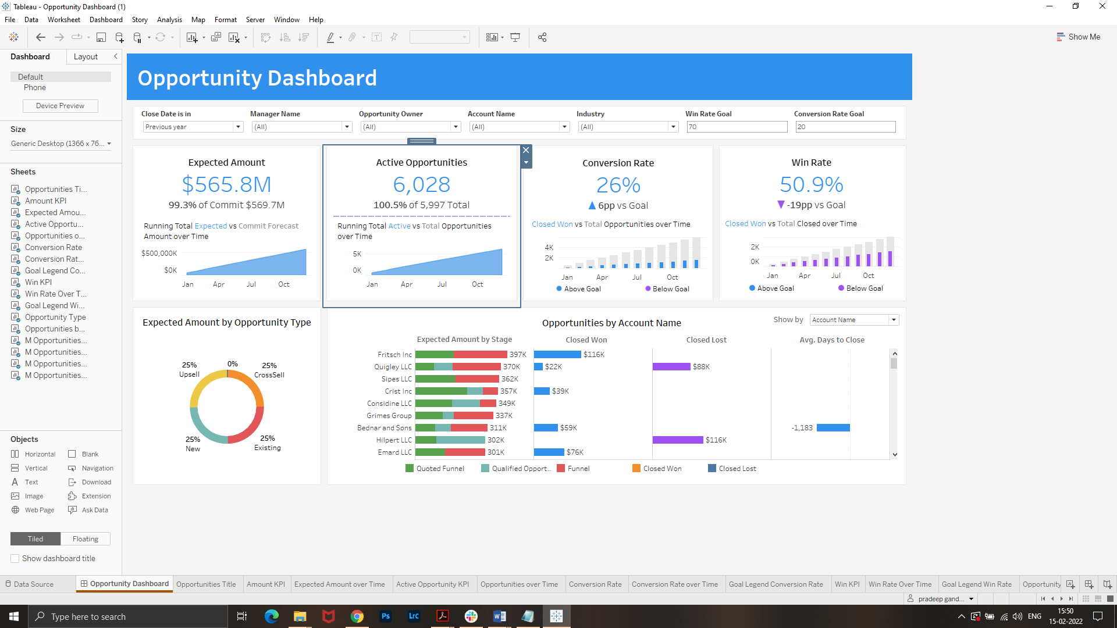

* **Pipeline Dashboard**

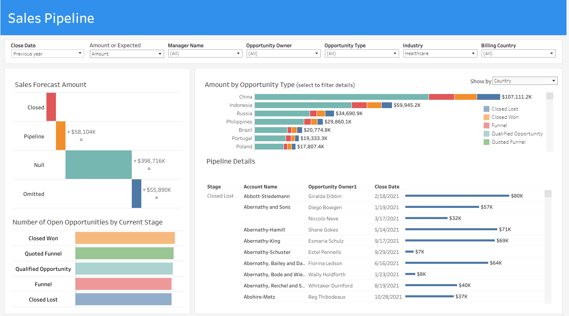

* **ERP Dashboard**

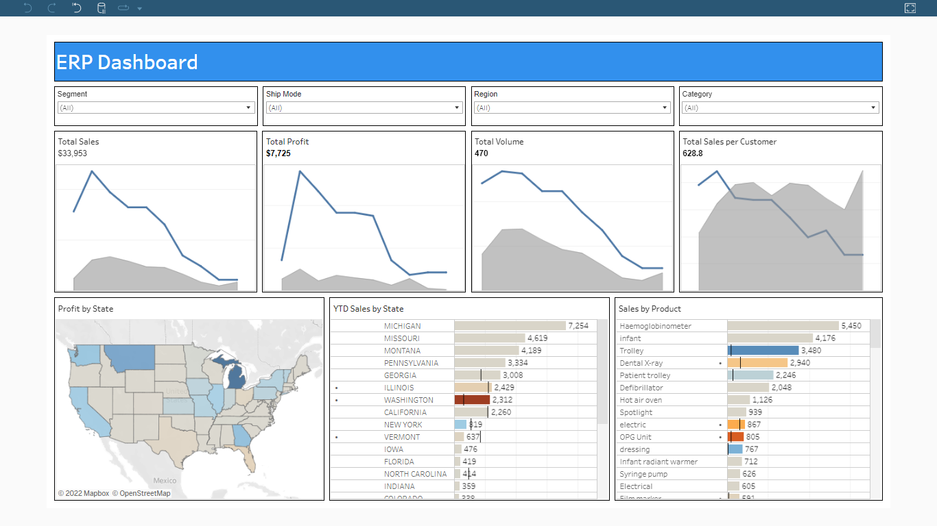

* The following screenshot shows the implementation of embedding the Tableau Dashboard over Client website

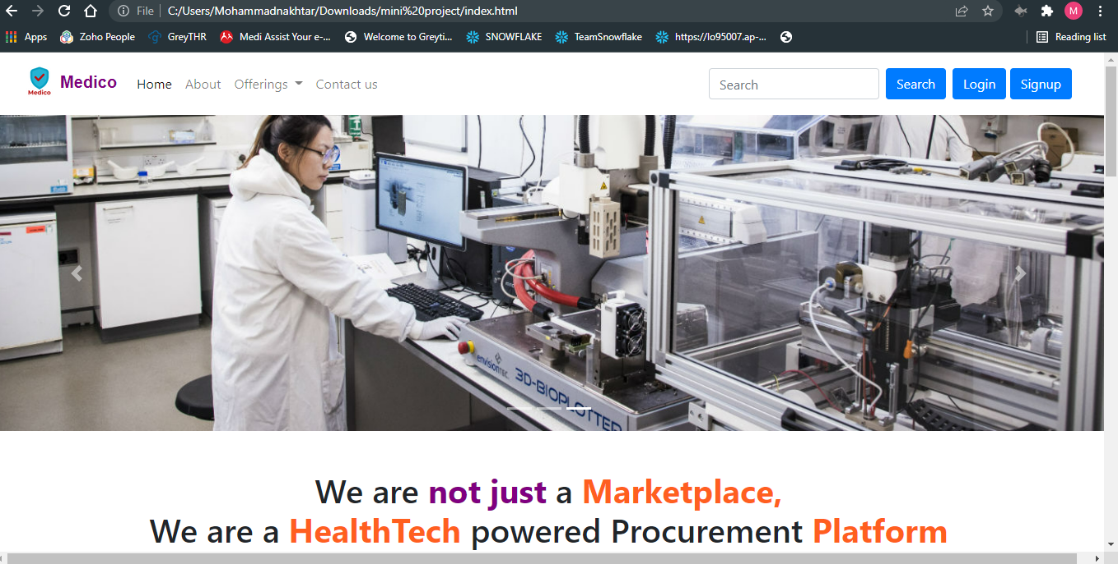

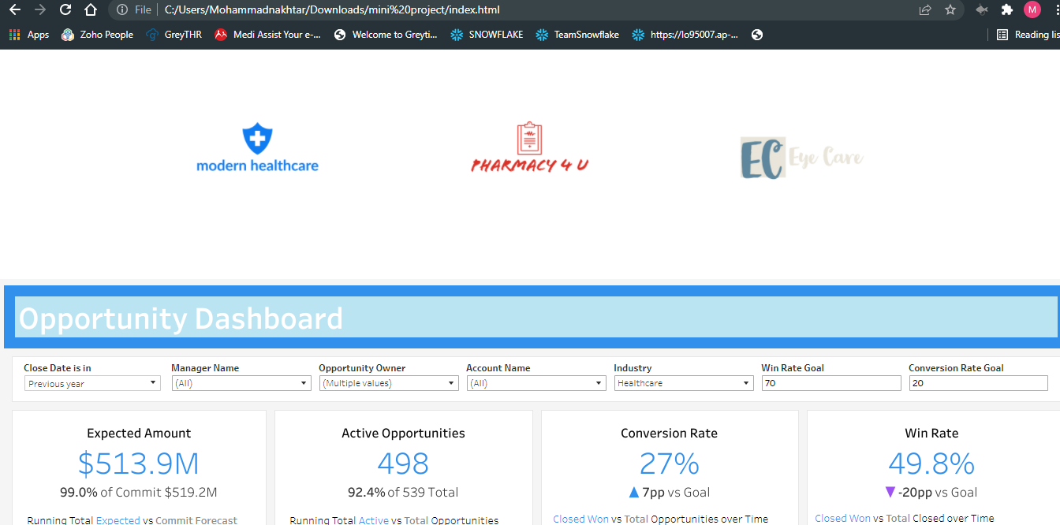

* The following is the screenshot of a subscription service we have created for the client users where they’ll get automated mails periodically for the views of the dashboards we created

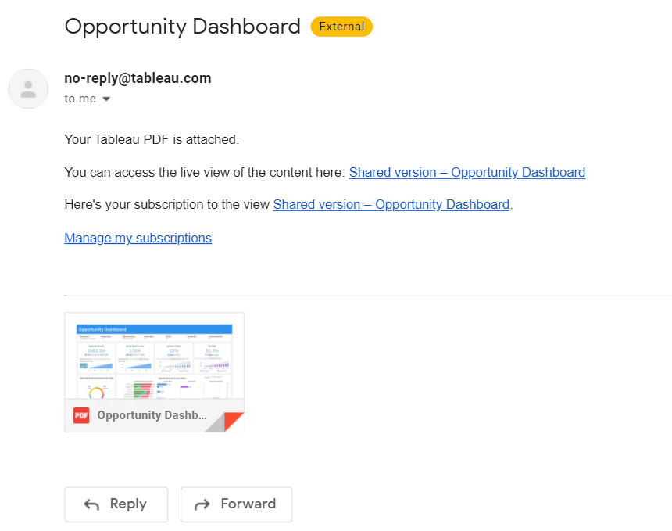

* **The following are the test cases for tableau**

| Test Case Scenario | Test Case ID | Test Steps | Expect Output | Actual Output | Result (PASS/FAIL) |
| --- | --- | --- | --- | --- | --- |
| Ensure that Pipeline Dashboard opens. | PP_DB_1 | 1. Open tableau with valid credentials.  2. Search for the Pipeline Dashboard and open the dashboard.  3. It navigates to the specific Pipeline Dashboard. | 1. Opens Pipeline dashboard as default with details as below.  => 1 gantt chart, 1 stacked bar and 2 horizontal bars showing No. of Open Opportunities by current stage and Pipeline details. | Dashboard opens properly | PASS |
|  |  |  |  |  |  |
| Ensure that all the filters, sheets and charts are properly aligned and all the spellings are correct | PP_DB_2 | Check all the filters, sheets ,charts and heading are aligned. | All the details should be aligned and spelled correctly. | Spelling, filters & titles are displayed correctly | PASS |
| To check Close Date and Manager Name filter selection option and applicability on charts. | PP_DB_3 | Open the Dashboard and change the Close Date and Manager Name filter. | Sales forecast amount, Amount by opportunity stage and Pipeline details should show the change according to the selection of Close Date and Manager Name filter. | Filters close date & manager name show proper data | PASS |
| To check Show by filter selection option and applicability on charts. | PP_DB_4 | Open the dashboard and change the Show by filter. | Stacked bar should show the change according to the selection of Close by filter. | Show by filter shows proper data | PASS |
| To check Amount or Expected filter selection option and applicability on charts. | PP_DB_5 | Open the dashboard and change the Amount or Expected filter. | Sales forecast amount and Amount by opportunity stage should show the change according to the selection of filter. | Expected amount filter working correctly | PASS |
| To check Opportunity Owner, Opportunity type, Industry and Billing country filter selection option and applicability on charts. | PP_DB_6 | Open the Dashboard and change Opportunity Owner, Opportunity type, Industry and Billing country. | Sales forecast amount, Amount by opportunity stage and Pipeline details should show the change according to the selection of Opportunity Owner, Opportunity type, Industry and Billing country filter. | Opportunity owner, type, Industry & billing country working properly | PASS |
| To calculate the amount collected by Billing Country and by Opportunity stage. | PP_DB_7 | 1. Open the dashboard.  2. Select the Opportunity stage filter.  3. Select 'Closed Lost' in the Opportunity stage filter.  4. Select the Billing Country filter and insert Afghanistan.  5. Check the expected amount collected by opportunity stage (i.e. Closed lost) and the Billing Country (i.e. Afghanistan). | The sheet should show the amount collected by opportunity stage (i.e. Closed lost) and the Billing Country (i.e. Afghanistan) and it should be equal to amount calculated manually in csv. | Calculated amount showing correct values | PASS |
| To check the amount by an account name. | PP_DB_8 | 1. Open the dashboard.  2. Select the Account Name filter  3. Check the amount. | The sheet should show the amount for the particular account name filtered and it should be equal to the amount manually checked in the csv. | Amount by account name showing correct amount | PASS |
| To check segment and ship mode filter selection option and applicability on charts. | ERP_DB_3 | Open the Dashboard and change the segment and ship mode filter. | Total sales, total profit, total volume, total sales per customer, Profit by state, YTD Sales by state and sales by product should show the change according to the selection of segment and ship mode filters. | All filters working correctly | PASS |
| To check Region and category filter selection option and applicability on charts. | ERP_DB_4 | Open the dashboard and change the REGION AND CATEGORY filter. | Total sales, total profit, total volume, total sales per customer, Profit by state, YTD Sales by state and sales by product should show the change according to the selection of region and category filters. | Region & category filter working correctly | PASS |
| To check the profit by state. | ERP_DB_5 | 1. Open the dashboard.  2. Select the state filter.  3. Check the profit by state. | The sheet should show the profit by state and it should be equal to the profit calculated manually in csv. | Profit by state is showing actual amount | PASS |
| To check the sales by Product name. | ERP_DB_6 | 1. Open the dashboard.  2. Select the Product Name filter  3. Check the sales. | The sheet should show the sales for the particular product name filtered and it should be equal to the sales manually checked in the csv. | Sales by product working properly | PASS |

**5.l Lead score predictor (Machine Learning)**

* The data we are analyzing contains the information of visits of customers on our client Medico's website and other media platforms. We are building an algorithm based on this data to find the potential customers who are interested in buying the products offered by Medico.
* Data cleansing is done using the Trifacta tool. Here unwanted columns and duplicate rows which are not useful in the algorithm are deleted.

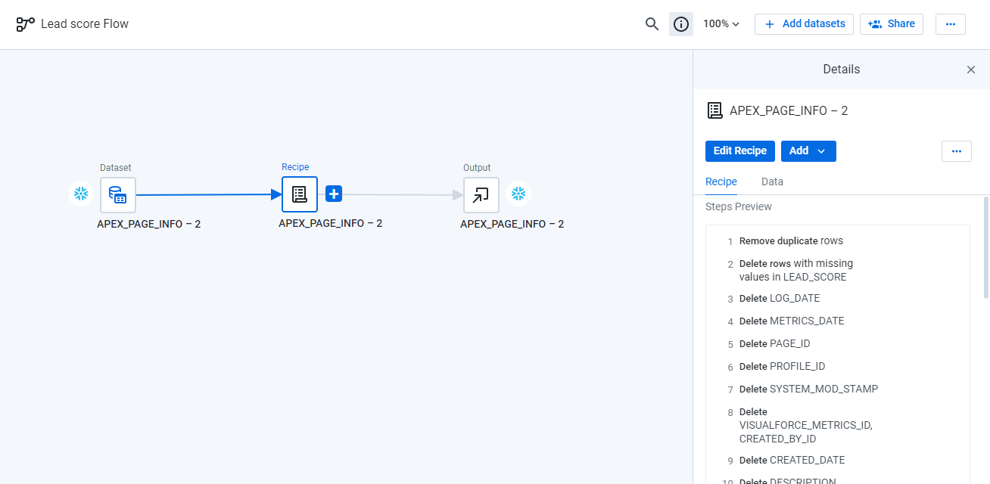

Using python to build the model. Installed python connector for snowflake to fetch the data from snowflake.

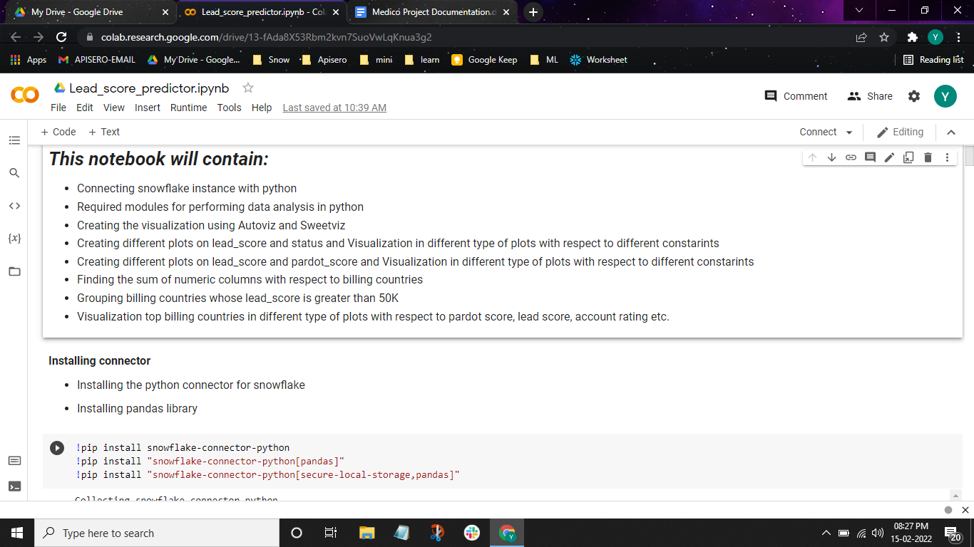

* Autoviz library takes data as input and finds the basic structure and identifies impactful features to plot visualizations. Below are a few examples of visualizations created through Autoviz.

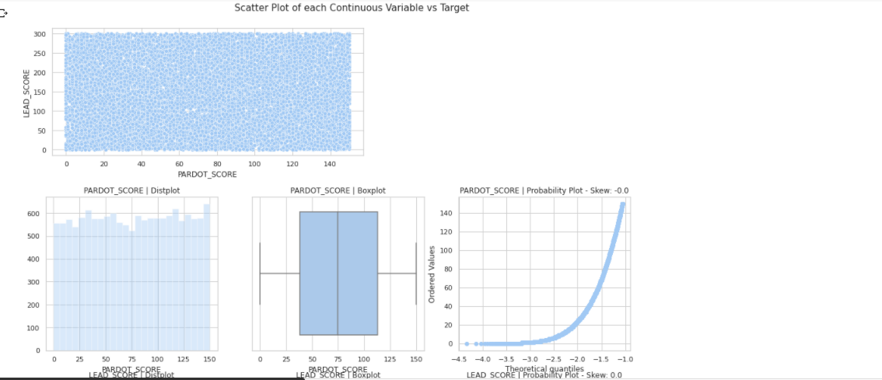

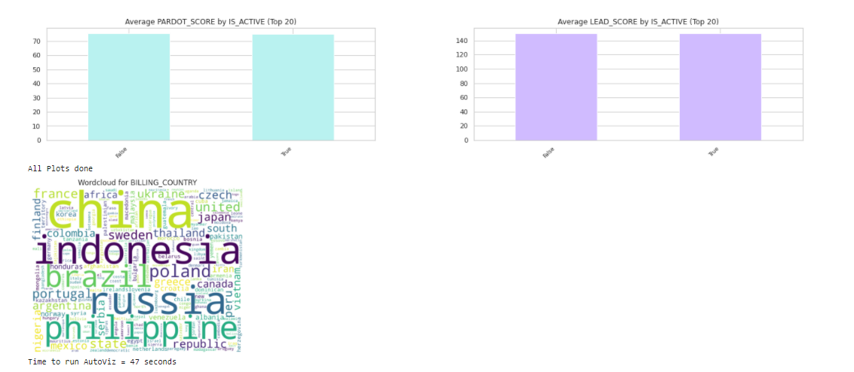

* Sweetviz is an open-source Python library that generates beautiful, high-density visualizations to kickstart EDA (Exploratory Data Analysis) with just two lines of code. Output is a fully self-contained HTML application. The system is built around quickly visualizing target values and comparing datasets.

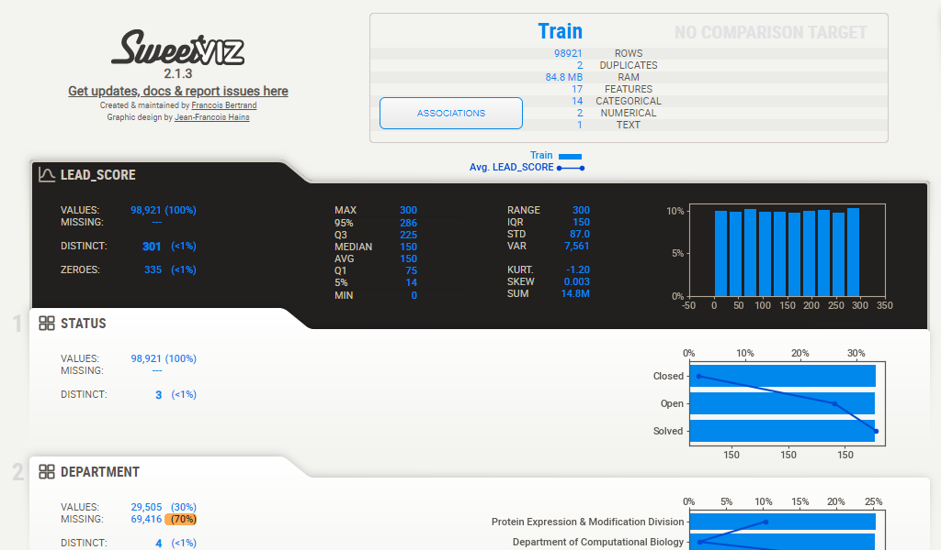

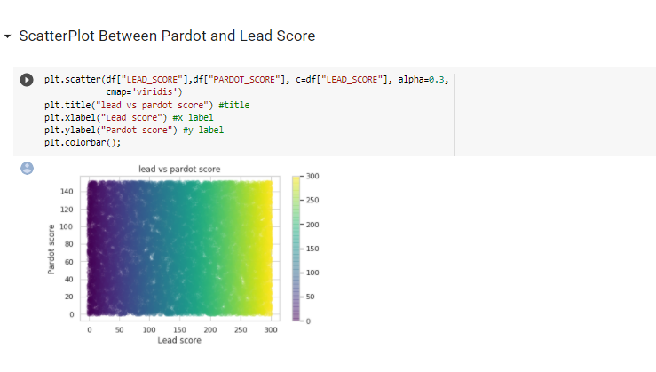

**Outcome of the Model**

Linear Regression and Random forest Regressor are used to build the models. Below are the test scores and other outcomes of the model.

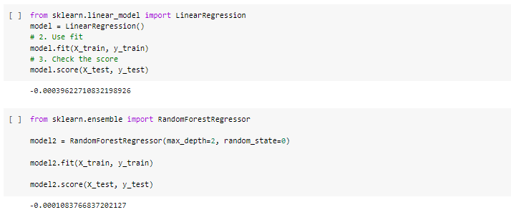

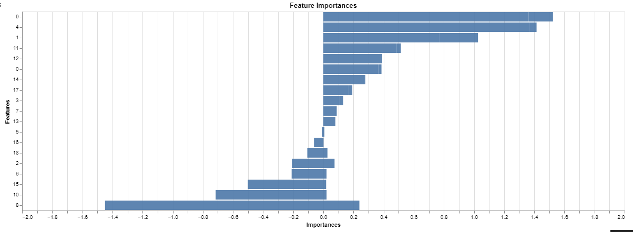

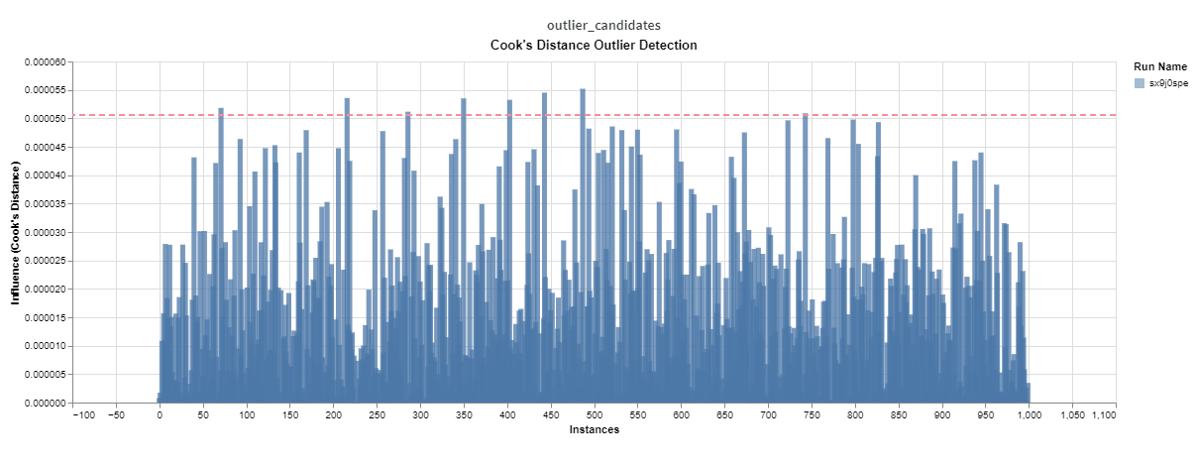

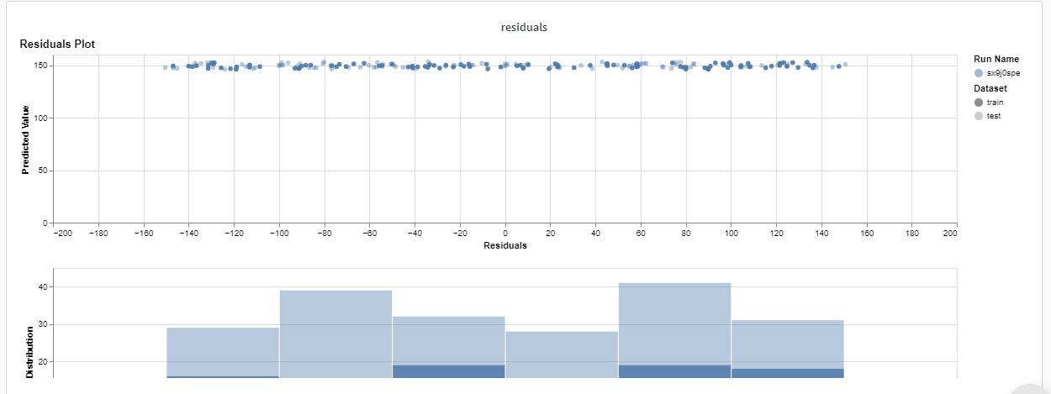

**5.m Sentiment Analysis (Machine Learning)**

* We are analyzing the feedback data received from customer reviews by our client and categories it into positive, negative and neutral.It helps our client to become more customer oriented and show the success by getting positive feedback.  
  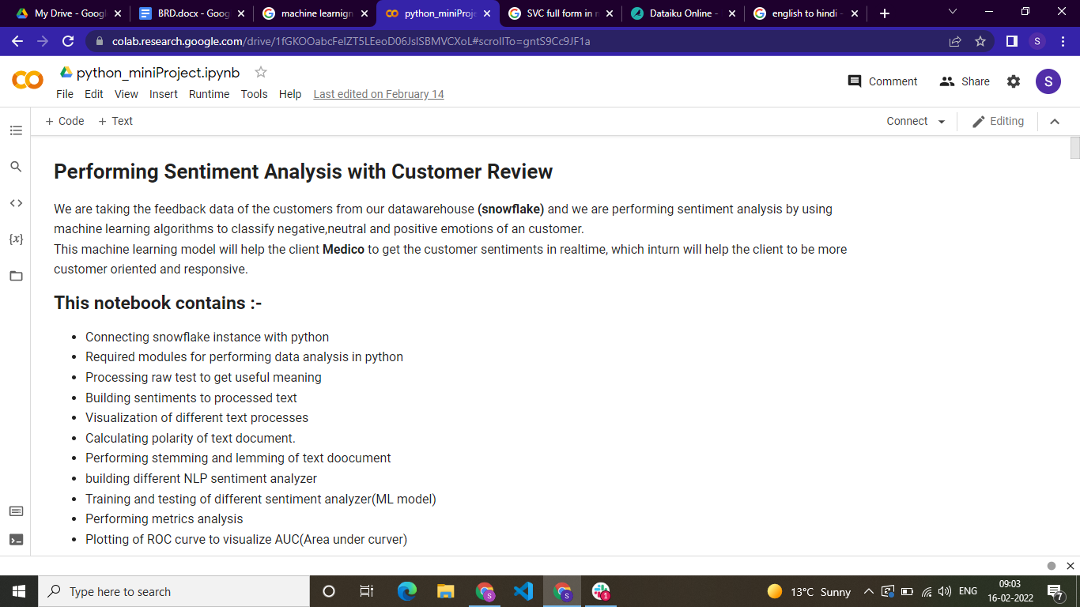
* We are loading the data from snowflake so we are making connections with it.  
  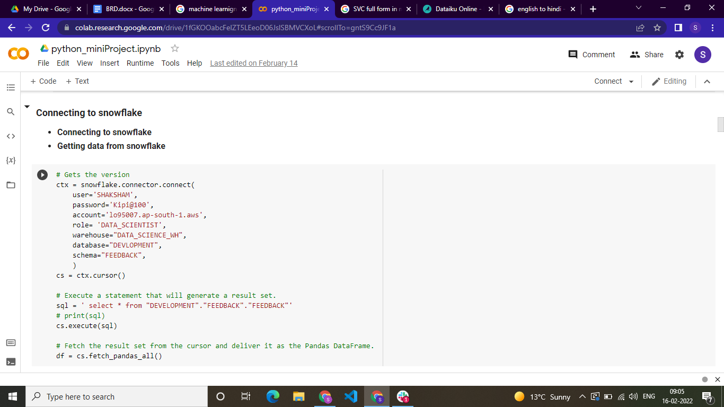
* Chart is to show density of sentiments  
  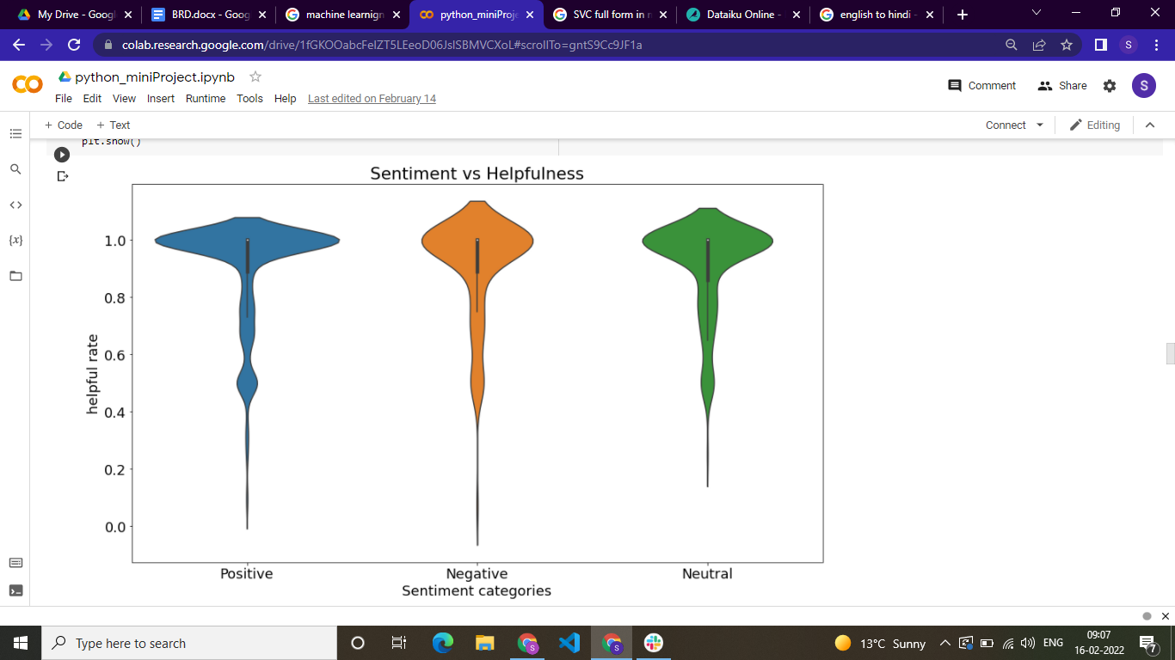
* Here this is the word cloud  
  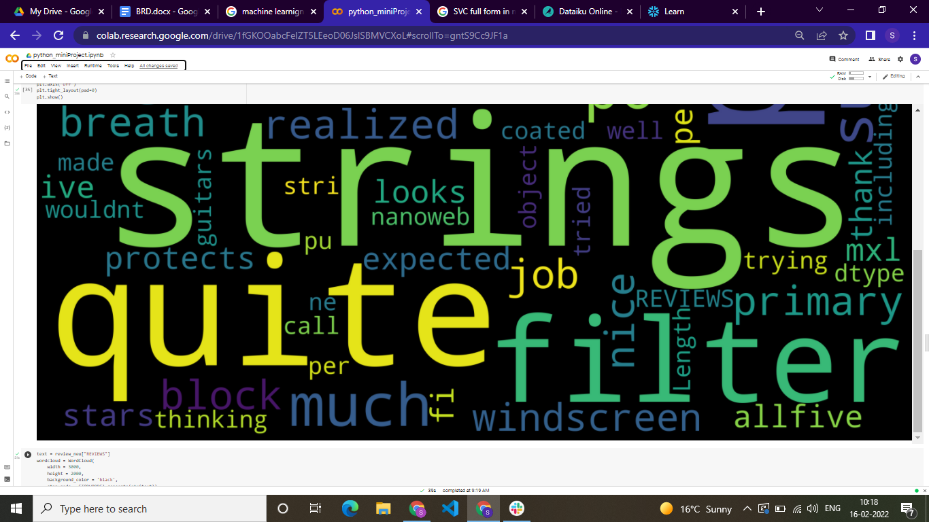
* Models are creating for Sentiment Analysis  
  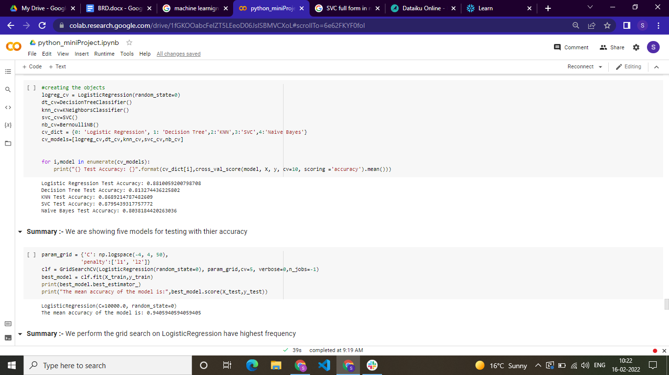
* The outcome of mode i.e. we are getting 95% of accuracy

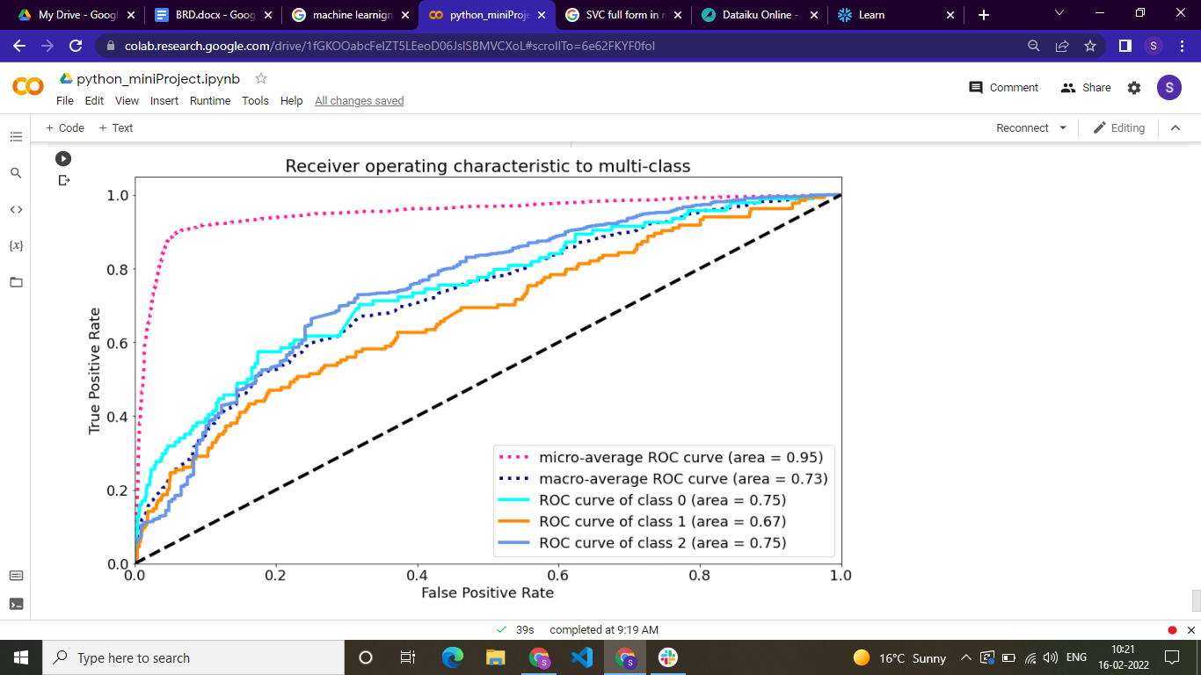

* **Testing :-** To check if the connection is made successfully and data is loaded correctly or not.

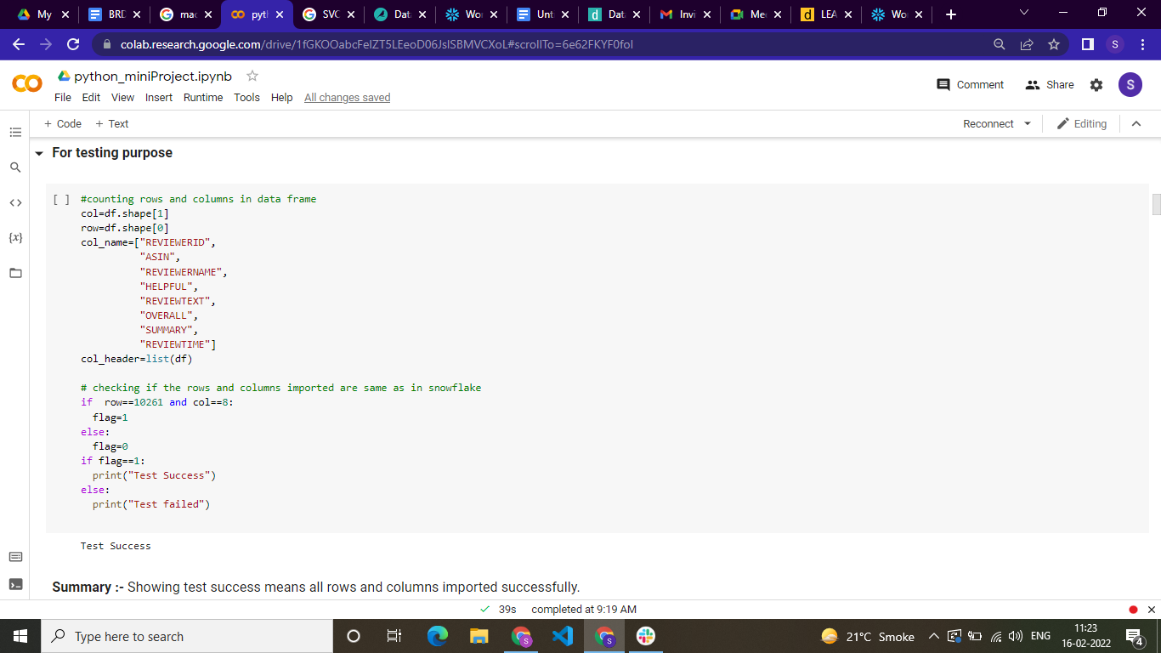

**5.n Dataiku (Enterprise Machine Learning)**

* In dataiku we are making Lead converter in which we are checking lead is converting or not.Too much lead information will staff get from various sources so it will be better if we done some automation where staff can focus on the potential cases where lead becomes opportunity so we are solving this problem by using dataiku.
* Here we are converting Lead table in Lead_Prepared  
  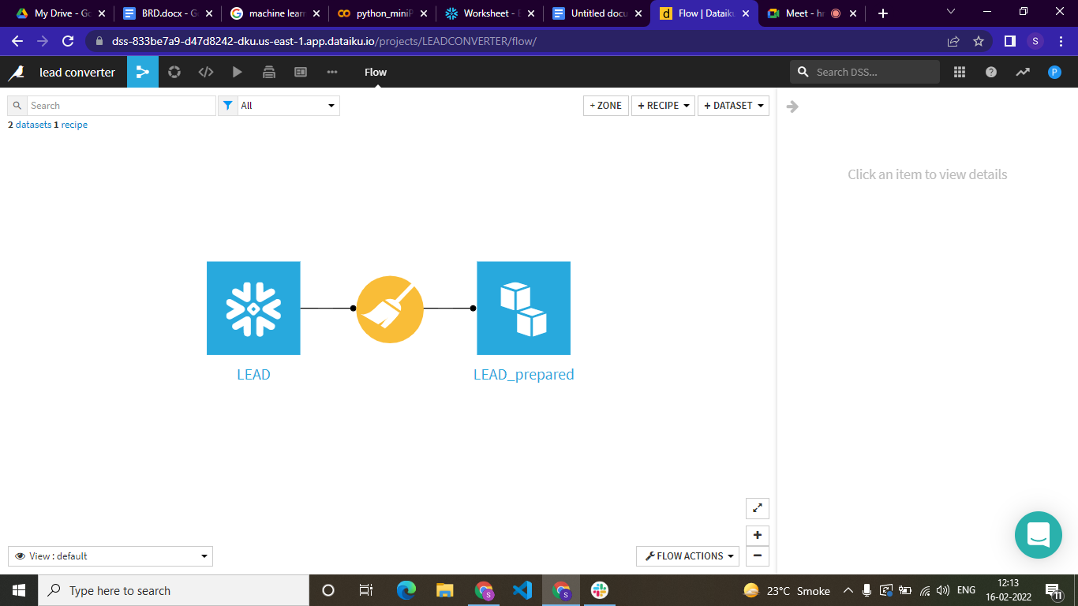
* We are creating 12 models and each model tells different features about that.

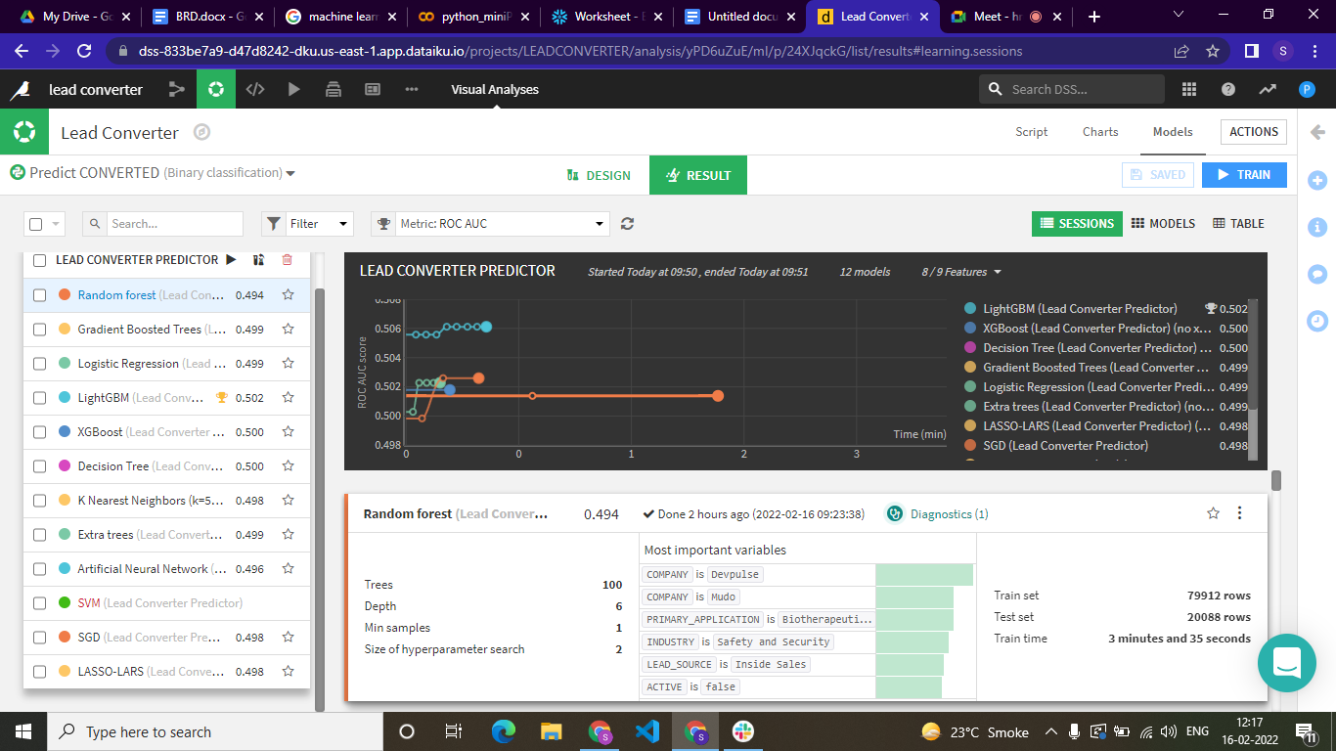

* To get insights of the data we created a dashboard  
  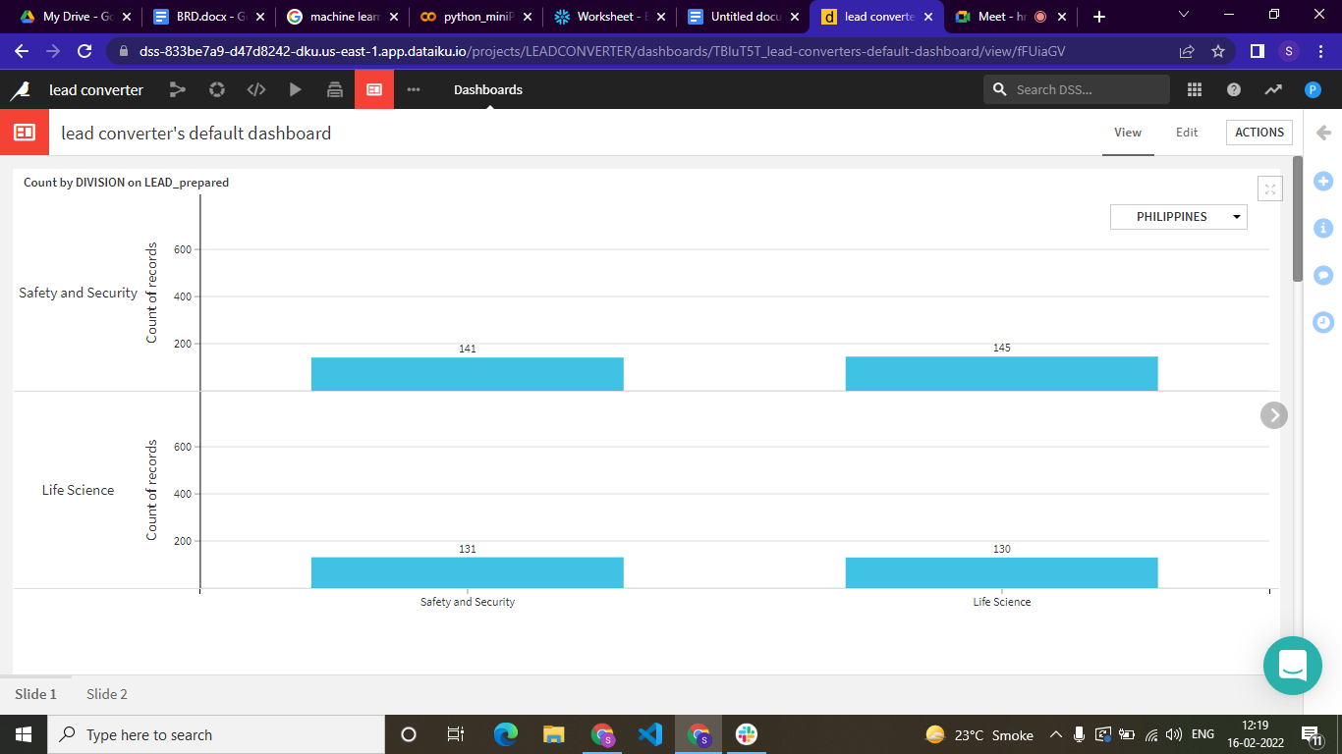

**5.o Sales forecasting Using R (Statistical Approach)**

Sales forecasting is the process of estimating future revenue by predicting the amount of product or services a sales unit has.

* This is a visualization of daily sales count

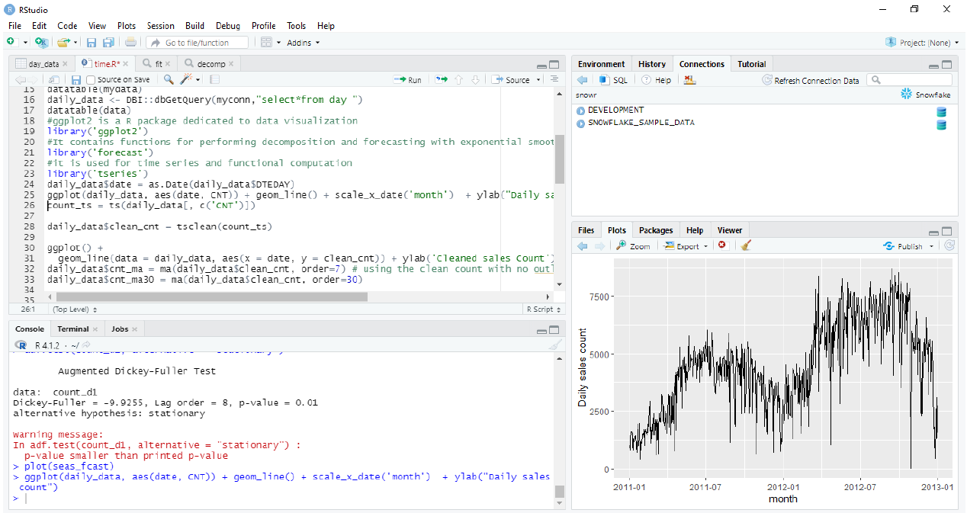

* Here we have daily data so we are visualizing smoothing series of weekly moving average or monthly moving average

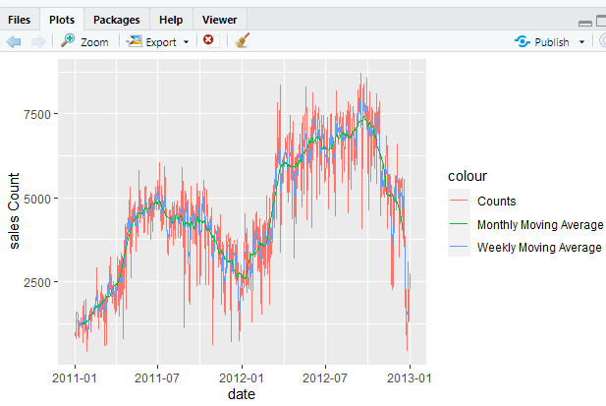

* Here decomposition separates the time series into the four components: the actual data plot, seasonal, trend and last one is random.

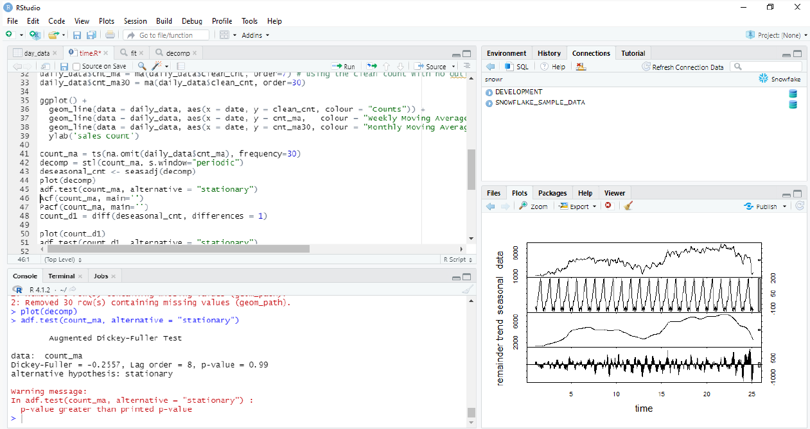

* To check the stationarity in time series we implement adf test here since p value is not less than 0.5 then the time series is not stationary



* acf compute an estimate of autocorrelation function

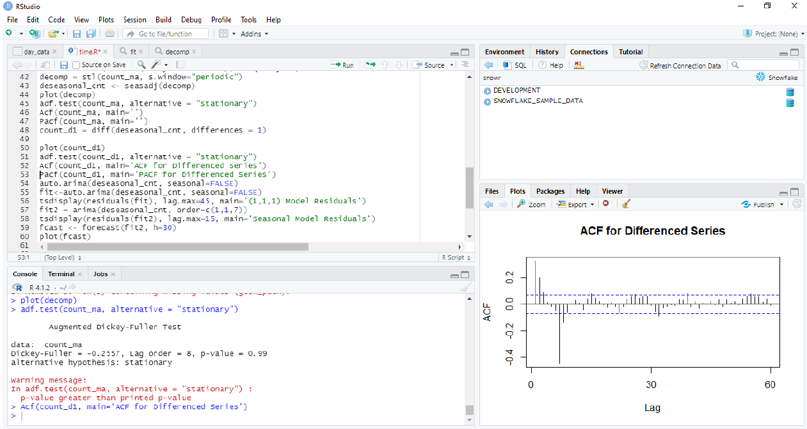

* pacf computes estimate of partial autocorrelation

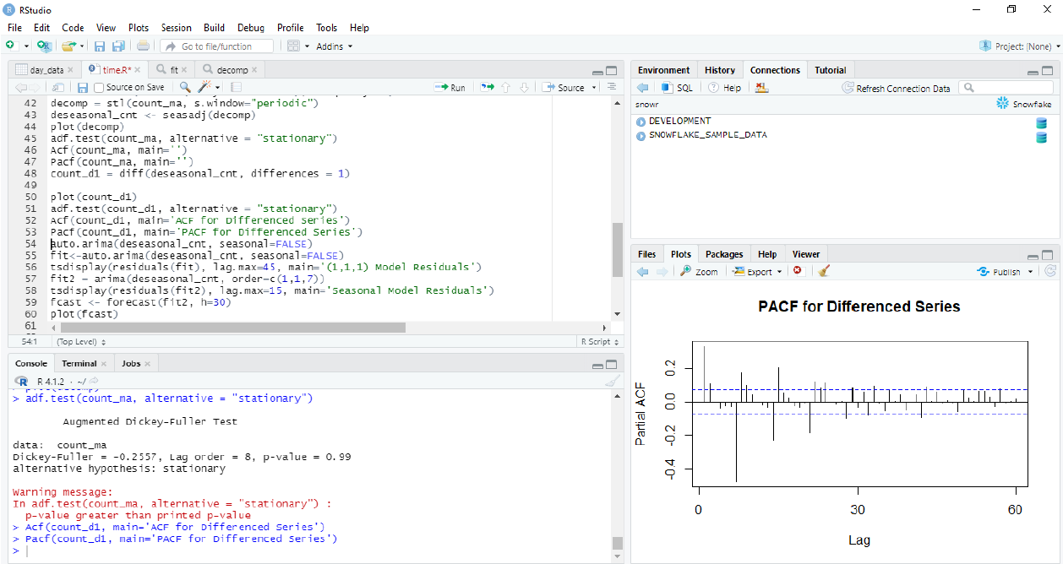

* Final arima model

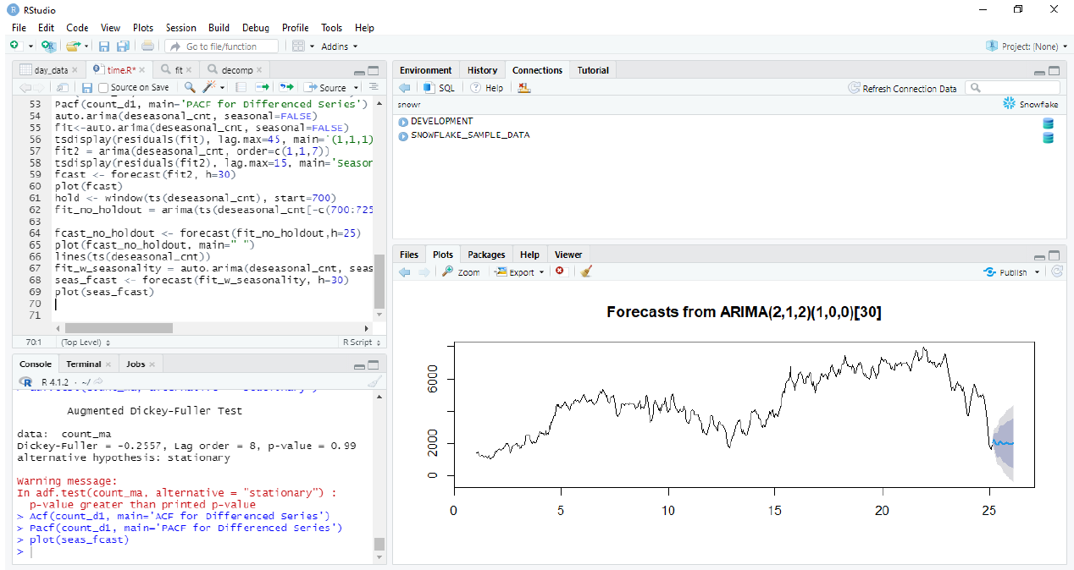

**5.p Word cloud using R (Data Science)**

A word cloud is a visual representation of a collage of words that represent the most frequently occurring words from a given table and views. This will give us an overview of an indirect summary of the products that the customers buy from the client. The following code snippet with its output will give a brief idea about the feedback from customers for the products sold by the client.

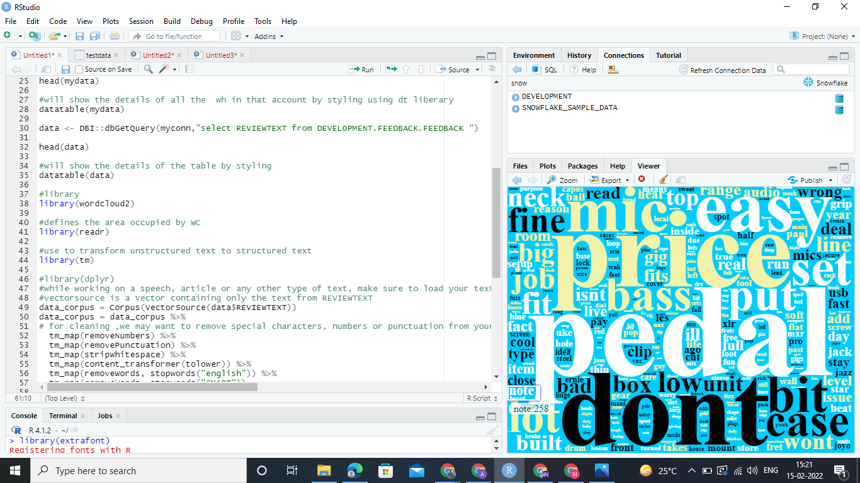

**5.q Bitbucket**

We are using Bitbucket to store all our scripts i.e. Snowflake,python,R,etc and documents in one repository. And here we have created separate branches for all the files so that it can be easily accessed.

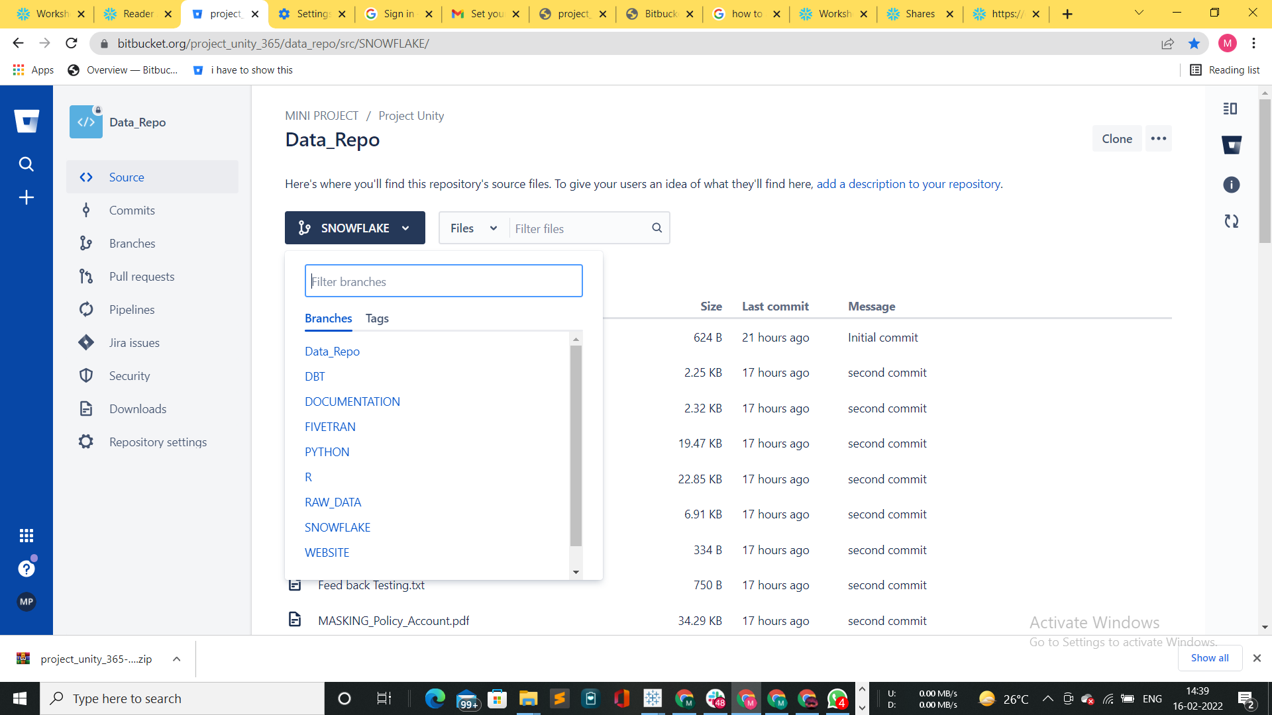

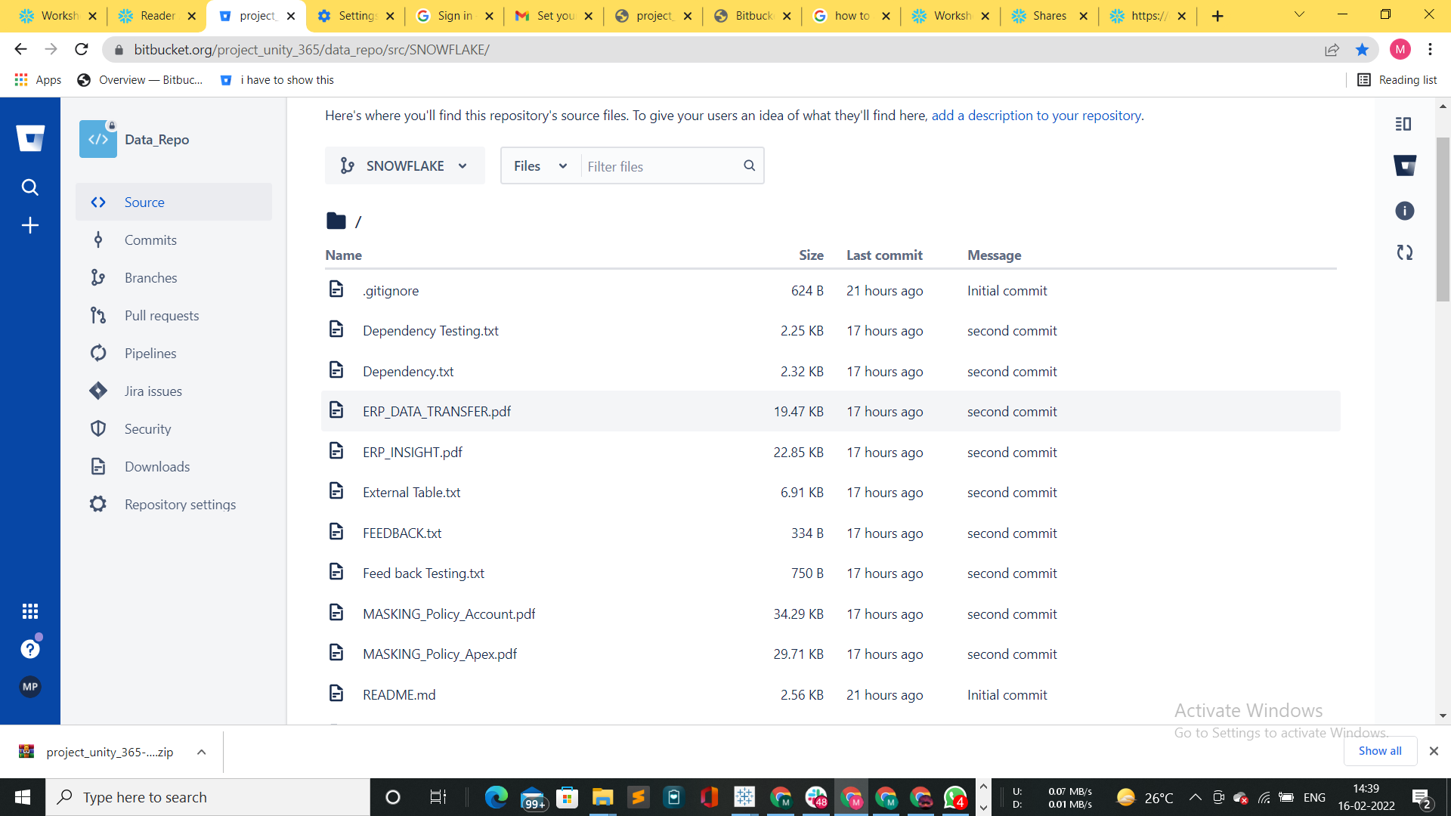

**6. CONCLUSION**

The project has made use of incorporating various tools & technologies to the extent possible based on the requirements specified by the client. The key points that can be understood from the implementation of end-to-end process of the project are as follows:

* The project proved to be cost effective (not quantifiable since it is subjective) since many of the transformations have been done using DBT rather than snowflake which helped in controlling the usage of credits in Snowflake
* The sales side of things have seen decent improvements with respect to the Conversion rate where the win rate still needs some tweaking to do internally by the sales department of the client
* Machine Learning models have significantly helped the client company to improve the relationship with their customer & provide better service using insights gathered from the data
* The client was able to deliver his requirement specifications from time to time with clear set goals which helped the development team to produce output in a quick & efficient manner
* The final and major problem faced by the client i.e., consolidating the data into one place and then analyzing it for further decision making in the business has been successfully resolved by the team from DSP consultancy